Experiment 10. Testing food samples for the presence of sugar (other than sucrose)
Food tests 10.01

(a) Prepare a water bath by half filling a beaker with water (hot water from the tap will
save time) and heating it on a tripod and gauze over a Bunsen burner. When the water boils, turn the flame down so that boiling point is just maintained.

(b) While waiting for the water to boil, draw up in your notebook a table like the one
below so that the results can be filled in as you obtain them.

(c) Label six test-tubes 1-6. If you use sticky labels, place these near the tops of the tubes so that they do not float off in the water bath.

(d) Crush about 1 cm cube, or equivalent volume, of the food in a mortar with about
5 cm³ (20 mm in a test-tube) of water. (If the sample is a liquid, simply pour 20 mm of it
into a test-tube.)

(e) Pour about 20 mm of the crushed mixture into a test-tube and add about 10 mm Benedict's solution.

(f) Place the test-tube in the water bath for 5-10 minutes and prepare the next food sample.

(g) Repeat the test with the remaining food samples and compare the colours produced in the test-tubes.

Enter the results in the table in your notebook.

Food sample | Colour change on heating with Benedict’s solution | Interpretation
1 Onion
2 Milk (or dried milk)
3 Rice
4 Raisin (or sultana)
5 Potato
6 Banana

CLEANING THE TEST-TUBES. If, after rinsing, a film of red cuprous oxide adheres to the
inside of the test-tubes, it can be removed with dilute hydrochloric acid followed by rinsing with water.

Experiment 10 Discussion.
Food tests 10.02

1 If a food sample, extracted and tested as in experiment 9, gives a yellow or red precipitate
on heating with Benedict's solution, can you assume that it therefore contains sugar of
some kind?

2 Does a yellow or red precipitate indicate that only a sugar is present and not starch or
protein?

If you did experiment 7 and/or experiment 8 answer questions 3 and 4.

3 Do your results enable you to say whether sucrose is present or absent in any of these
food samples?

4 If one of the samples gave no reaction on heating with Benedict's solution, what further
tests could you do to see if sucrose was present?

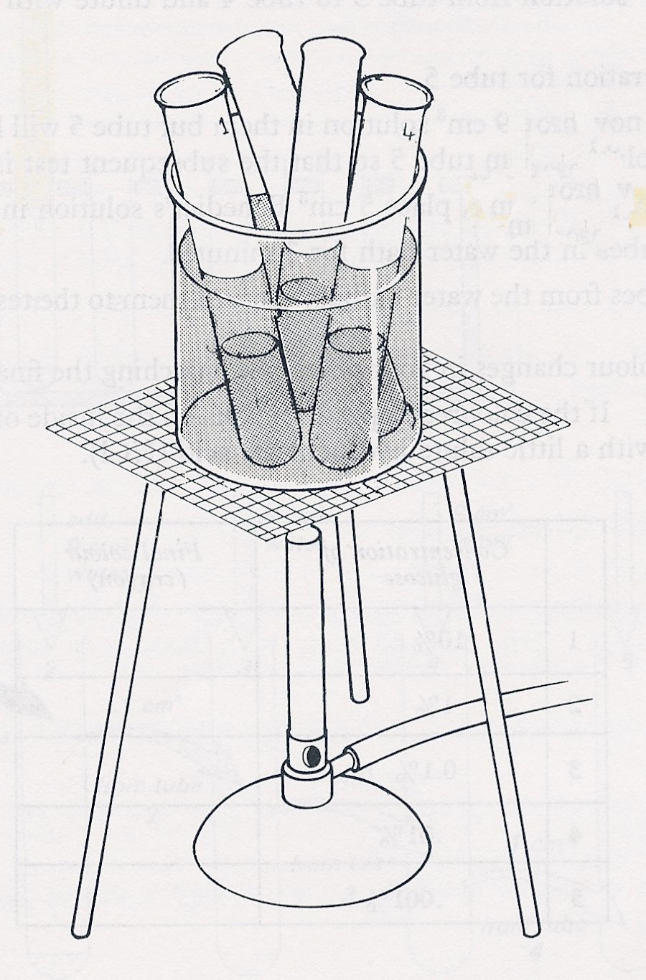

Using the water bath

Experiment 10 Testing food samples for the presence of sugar (other than sucrose) - preparation
Food tests 10.03

Outline Samples of food are crushed in water and tested with Benedict's solution

Prior knowledge The Benedict's reaction,
Advance preparation and materials

Food samples as in the table on p. 9.01
Benedict's solution 50 cm³ per group
(If seeds are to be used, they should be soaked for 24 hours beforehand):

Apparatus-per group

test-tube rack and 6 test-tubes tripod
small mortar and pestle gauze
test-tube brush heat resistant mat
6 watch-glasses for samples 6 labels or spirit marker
250 cm³ beaker or tin can for water bath

-per lab.
One or two balances, weighing to 1g if samples are to be weighed.

Experiment 10. Discussion - answers

1 A red precipitate in this context is indicative of a sugar (reducing sugar).

2 The test gives no information about proteins and starch which could be present in addition to sugar.

3 Sucrose could be present in any of the samples but the results here will not indicate either its presence or absence.

4 To detect sucrose, the food sample would have to be boiled with dilute hydrochloric acid and then tested with Benedict's reagent. A red precipitate would indicate that sucrose had been present but only if no other sugar had been detected in the previous experiments.

