Food tests 13.01
Experiment 13 General tests on food samples

In experiments 6, 10, 11 and 12, different kinds of food have been tested, but in each case
only one class of food was being sought. The type of investigation most likely to be under-
taken by a biologist is one in which a food sample is tested for all possible classes of food.

(a) Draw up a table like the one below, in your notebook, for each sample of food you
propose to test.

(b) Divide the food sample into two unequal portions, approximately 3: 1 in volume.

EXTINGUISH ANY BUNSEN FLAME.

(c) Crush the smaller portion of food in a dry mortar and pestle with about 10 cm³ alcohol. (propan-2-o1). Filter into a dry test-tube and pour half the filtrate into about 10 mm
water in a test-tube. Record your observations. (The test for fats is described fully
on p. 12.01.) Dispose of the filter paper in the receptacle provided.

(d) Return to the larger portion of food and crush it in a mortar and pestle with about
20 cm³ water (about 100mm in a test-tube).

(e) Label three test-tubes 1-3 and share the crushed mixture between them so that each
contains about 20 mm of liquid.

(f) See that no alcohol remains on your bench and then light the Bunsen burner.

(g) To tube 1 add about 10 mm Benedict's solution. Heat gently over a small Bunsen flame
till the mixture boils. (For full details of this test see p. 10.03.) Record your observations.

(h) Tube 2. Add about 5 mm sodium hydroxide solution and 5 mm dilute copper sulphate solution. Shake the tube from side to side. (Fuller account on p. 11.01.)

(i) Boil the contents of tube 3. Cool under the tap and add five drops of iodine solution. (Full details of this test are on p. 6.01.) Record your observations.

Food sample ……………………………………………………
Test | Result | Interpretation
Extracted in alcohol and poured into water
Benedict’s solution
Biuret reaction
Iodine

Experiment 13. Discussion
Food tests 13.02

1 For what reasons do you think a biologist would want this information?

2 To what use could he/she put the information?

3 What other facts about food samples is he/she likely to need to know?

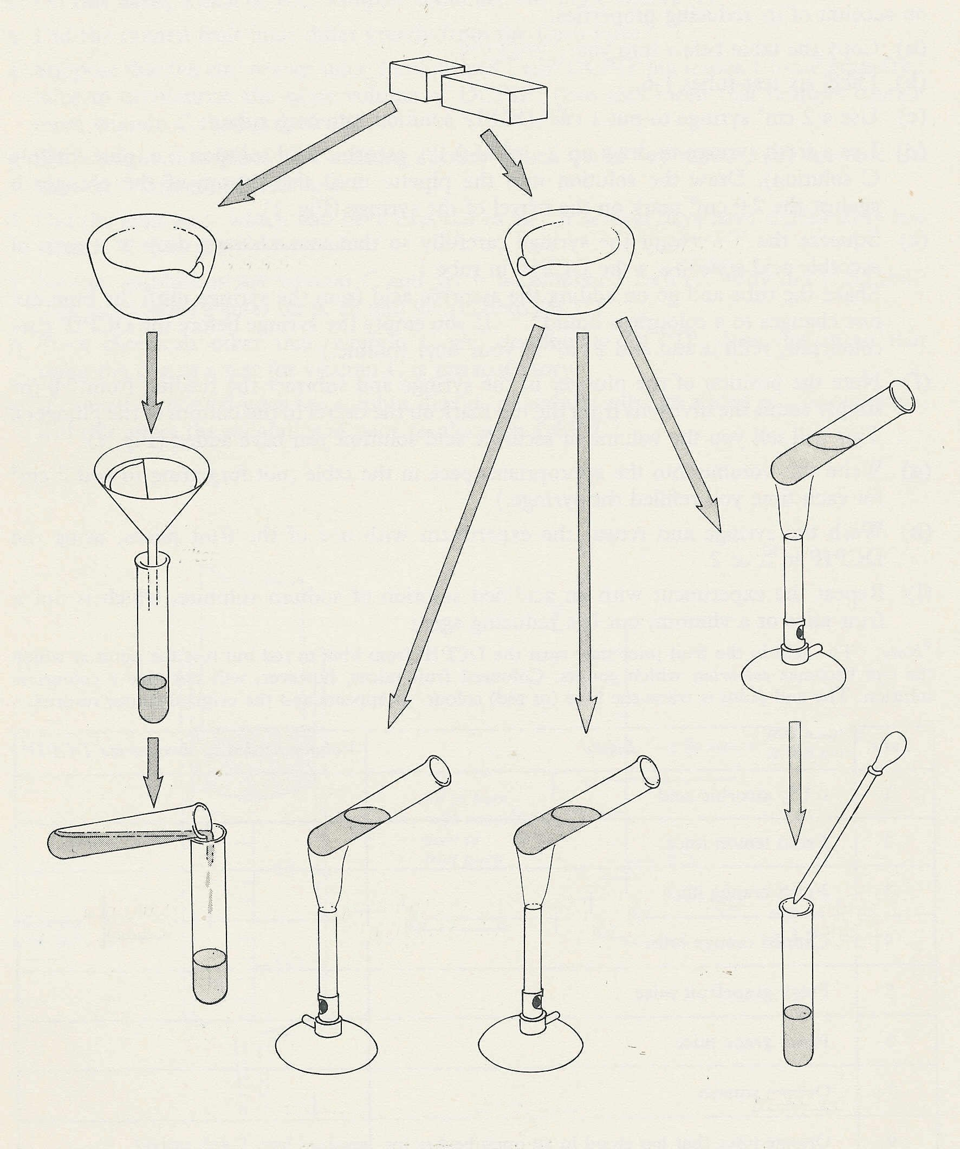
food sample
¼
¾

extract with alcohol
extract with water

filter
boil

cool

pour filtrate
into water
heat with Benedict’s solution
biuret test
add iodine

FATS

SUGAR
PROTEIN
STARCH
(other than
sucrose)

FATS
SUGAR*
PROTEIN
STARCH
* other than
sucrose
Experiment 13. General tests on food samples - preparation
Food tests 13.03

Outline Food samples are extracted with alcohol or water and tested for fats, reducing sugars, protein and starch.

Prior knowledge Familiarity with food tests, e.g. experiments 6, 10, 11 and 12.

Advance preparation and materials

food samples (preferably different from those already tested)
iodine solution
Benedict's solution 15 cm³ per group
copper sulphate solution and 10% or 2N sodium hydroxide solution
propan-2-ol 20 cm³ per group

Apparatus-per group

test-tube racks and 6 test-tubes small mortar and pestle
3 labels or spirit marker dropping pipette
test-tube holder 2 or 3 watch glasses (for samples)
test-tube brush filter funnel
Bunsen burner filter papers (2 or 3)

NOTE. To minimize fire risks it is suggested that the students collect 10 cm³ alcohol from a central point each time they need it rather than keep a supply on the bench where Bunsen burners will be used. Similarly, a receptacle for the alcohol-soaked filter papers should be provided.

Experiment 13. Discussion - answers

1 & 2 If the biologist knows the relative contents of food he can make recommendations about diets suitable for people in different circumstance, e.g. he can point out that tropical foods such as yam and cassava are rich in starch but lacking in protein and are thus quite unsuitable as a
staple diet for young children.

3 He will need to know (a) the relative quantities of each food class as well as whether it is present or absent, (b) the vitamin content, (c) the calorific value, (d) the mineral salts present,
(e) the proportion of roughage.

