Experiment 8. The hydrolysis of starch with hydrochloric acid
Enzymes 8.01

(a) Prepare a water bath by half filling a 250 cm³ beaker with warm water and heating it to boiling point on a tripod and gauze, with a Bunsen burner. When the water boils, reduce the flame to keep the water at boiling point.

(b) Label four test-tubes 1-4.

(c) Copy the table given below into your notebook.

(d) In each tube place 5 cm³ 3% starch solution.

(e) Using a syringe or graduated pipette, add 3 cm³ Benedict's solution to the starch solution in
tube 1 and place the tube in the boiling water bath for five minutes.

(f) Rinse the syringe or pipette and use it to add 1 cm³ dilute hydrochloric acid to the starch solution in each of tubes 2, 3 and 4. Note the time and place all three tubes in the water bath.
(They will be removed at five, ten and fifteen minutes respectively).

(g) Remember to remove tube 1 from the water bath after five minutes if you have not
already done so.

(h) After five minutes, remove tube 2 from the water bath and cool it under the tap. Neutralize the acid by adding solid sodium bicarbonate, a little at a time, until the addition of one portion produces no fizzing. Place tube in the rack and return to tube 3.

(i) After ten minutes in the water bath, remove tube 3, cool and neutralize the contents as described in (h). Place the tube in the rack.

(j) After fifteen minutes in the water bath, remove tube 4; cool and neutralize as before, and place it in the rack.

(k) With a dropping pipette, remove a sample of the liquid from tube 2 and place 3 drops
on a spotting tile. Rinse the pipette and repeat the procedure for tubes 3 and 4. Add
one drop of dilute iodine to each drop of liquid on the tile.

(l) Rinse the syringe or pipette and use it to place 3 cm³ Benedict's solution in each of
tubes 2, 3 and 4. Return all three tubes to the water bath and heat for five minutes.
After this time replace the tubes in the rack and allow them to cool sufficiently to
handle. Hold the tubes to the light to compare the colours of the solutions and compare
also the colours and relative quantities of any precipitates.

 |  |  | Appearance after testing with Benedict’s
Tube | Containing | Appearance with iodine | Colour of solution | Colour of precipitate | Relative quantity of precipitate
1 | 3% starch solution only
2 | 3% starch solution boiled for 5 min with dilute HCL
3 | 3% starch solution boiled for 10 min with dilute HCl
4 | 3% starch solution boiled for 15 min with dilute HCl

Experiment 8. Discussion
Enzymes 8.02

1 What was the point of adding sodium bicarbonate to tubes 2, 3 and 4?

2 What food substance is Benedict's solution a test for?

3 At the end of the experiment, what food substance was present in tubes 3 and 4 that
was not there at the beginning?

4 What evidence have you that this substance was not present at the beginning of the
experiment?

5 How do you account for the difference, after testing with Benedict's solution, between
tubes 2, 3 and 4?

6 How do you interpret the results of the iodine test in tubes 2, 3 and 4?

7 What relationship is there between the interpretation of the results with the iodine test and the Benedict's test?

8 The starch molecule consists of a long chain of carbon atoms with hydrogen and oxygen
atoms attached. Sugars, such as glucose, consist of six carbon atoms with hydrogen and oxygen atoms attached.

part of a starch molecule*
glucose molecule*

(*many H atoms omitted)
Assuming that the hydrochloric acid is acting only as a catalyst in the reaction, attempt
an explanation of the chemical change which takes place in tubes 3 and 4.

9 In this experiment, the emphasis is on the conversion of starch to something else using
hydrochloric acid. What control experiment would have to be carried out to show that
hydrochloric acid played a significant part in bringing about this change?
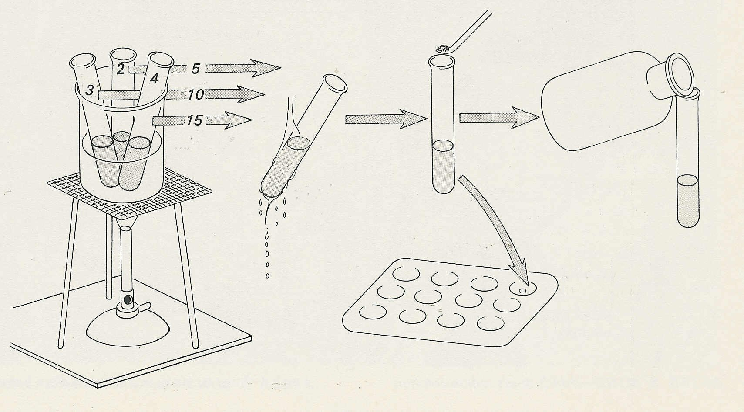
Starch and hydrochloric acid
remove after
minutes
cool
add sodium bicarbonate
test with Benedict’s
test sample with iodine

Experiment 8. The hydrolysis of starch with hydrochloric acid - preparation
Enzymes 8.03

Outline. The experiment illustrates the conversion of starch to a reducing sugar by the action of hydrochloric acid at boiling point. The longer the starch is exposed to the acid the further hydrolysis proceeds. The experiment is intended to show the contrast with enzymes, which do not need high temperatures and prolonged exposure to reagents and give a quick reaction.

Prior knowledge. Benedict's reaction, starch/iodide reaction.

Advance preparation and materials-per group

3% starch solution, freshly prepared* 25cm³ sodium hydrogencarbonate (bicarbonate)
Benedict's reagent 20 cm³ powder about 5 g
dilute hydrochloric acid, 2M or 10% iodine solution (dilute) 5 cm³ ⁺
(bench strength) 5 cm³

* NOTE. Some brands of starch are readily hydrolysed and might give a positive reaction with tube 1. A 3% starch solution should be tested with Benedict’s solution to see if it withstands hydrolysis after 5 minutes in a water bath.

Apparatus - per group

test-tube rack and 4 test-tubes tripod
4 labels or spirit marker gauze
graduated pipette or syringe 10 cm³ heat mat
250 cm³ beaker spatula for adding sodium hydrogencarbonate
Bunsen burner dropping pipette (if not supplied with iodine bottle)

- per class

clock

Time The experiment needs from 30-45 minutes

⁺ See instructions for making dilute iodine on p. 01

Experiment 8. Discussion - answers
Enzymes 8.04

1 The hydrogencarbonate neutralizes the hydrochloric acid which would otherwise interfere with Benedict's reagent.

2 Benedict's solution is a test for reducing sugars.

3 Tubes 3 and 4 should have a red precipitate, indicative of a reducing sugar.

4 Tube 1, containing starch solution, should have given little or no colour change with Benedict's
solution.

5 Tube 4 will probably have a more intense red colour or a more dense precipitate than the others, indicating that a greater quantity of reducing sugar has been formed. The liquid in tube 2 may still be blue, indicating unchanged Benedict's solution.

6 The blue colour is progressively less intense or absent altogether in tube 4 indicating that starch is 'disappearing'.

7 In tube 4, at least, starch has disappeared and sugar has appeared. It could be that:
(i) Hydrochloric acid has changed starch into sugar.
(ii) Hydrochloric acid has combined with starch to form sugar.
(iii) Starch has converted hydrochloric acid to sugar.

8 If students are not overwhelmed by the sight of the structural formulae they might notice that
by breaking the starch chain at the -0- linkages, adding H- to one side and -OH to the other, glucose molecules would be produced. The possibility of disaccharides is ignored at this juncture.

9 To show that starch solution is not converted to sugar by simply boiling it, a control should be carried out by boiling 5 cm³ 3% starch solution for 10 minutes and then testing with Benedict's
reagent.

