Experiment 9. The action of saliva on starch
Enzymes 9.01

Study the flow chart on p. 9.02 for a few minutes to gain an idea of the outline of the experiment.

(a) Prepare a water bath by using a Bunsen burner to heat some water in a beaker on a
tripod and gauze till it boils; then turn the flame down to keep the water just boiling. While waiting for the water to boil, carry on from (b).

(b) Label eight test-tubes 1 - 8 and in tube 1 collect saliva as follows:

(i) Thoroughly rinse the mouth with water to remove food residues
(ii) Collect about 50 mm saliva.

(c) Pour half the saliva into tube 2 and place the tube in the boiling water bath for 3 minutes.

(d) Using a graduated pipette or syringe, add 5 cm³ 2% starch solution to tubes 3,4 and 7.

(e) Rinse the pipette or syringe and use it to transfer 5 cm³ boiled saliva from tube 2 to tube 3. Shake the tube sideways to mix the contents.

(f) Use the graduated pipette or syringe to transfer 5 cm³ unboiled saliva from tube 1 to tube 4.
Shake the tube to mix the contents.

(g) Leave tubes 3 and 4 to stand for five minutes and copy the table below into your notebook.

(h) After five minutes, pour half the contents of tube 3 (the boiled saliva and starch) into tube 5 and add three drops of iodine solution to tube 5.

(i) To the remaining liquid in tube 3, add about 20 mm Benedict's solution and place
the tube in the boiling water bath for 5 minutes.

(j) Pour half the contents of tube 4 (starch and saliva) into tube 6 and then add three drops of iodine to tube 6.

(k) Test the remaining liquid in tube 4 with Benedict's solution as you did in (i).

(l) Pour half the contents of tube 7 (starch solution) into tube 8 and test the two samples
respectively with iodine as in (h) and Benedict's solution as in (i). Record the results in your table.

Tube | Contents | Tested with | Result | Interpretation
3 | starch and boiled saliva | Benedict’s solution
4 | starch and saliva | Benedict’s solution
5 | starch and boiled saliva | iodine
6 | starch and saliva | iodine
7 | starch solution (control) | iodine
8 | starch solution (control) | Benedict’s solution

Experiment 9. Discussion
Enzymes 9.02

1 What substances do iodine and Benedict's solution test for?

2 What change takes place when starch and saliva are mixed, according to the results in tubes 4 and 6?

3 Tubes 3 and 5 probably did not give the same results as tubes 4 and 6. In what way were the contents treated that could account for this difference?

4 (a) Are your results consistent with the hypothesis (theory) that an enzyme in saliva
has changed starch to sugar?
(b) Do your results prove that an enzyme in saliva has changed starch to sugar?

5 In what way do the results with tubes 3 and 5 support the enzyme hypothesis?

6 Do your experimental results rule out the possibility that (a) starch converts unboiled saliva to sugar or (b) starch and unboiled saliva combine chemically to form sugar?

7 The starch molecule consists of a long chain of carbon atoms with oxygen and hydrogen
atoms attached. A sugar, such as glucose, has molecules consisting of six carbon atoms
with oxygen and hydrogen atoms attached (see p. 8.02). Using this information, suggest a
way in which sugar could be formed from starch. What part would an enzyme play in
this reaction?

8 If you tried experiment 8, state in what ways the conditions for the reaction between starch and hydrochloric acid differed from those in the starch/saliva reaction.
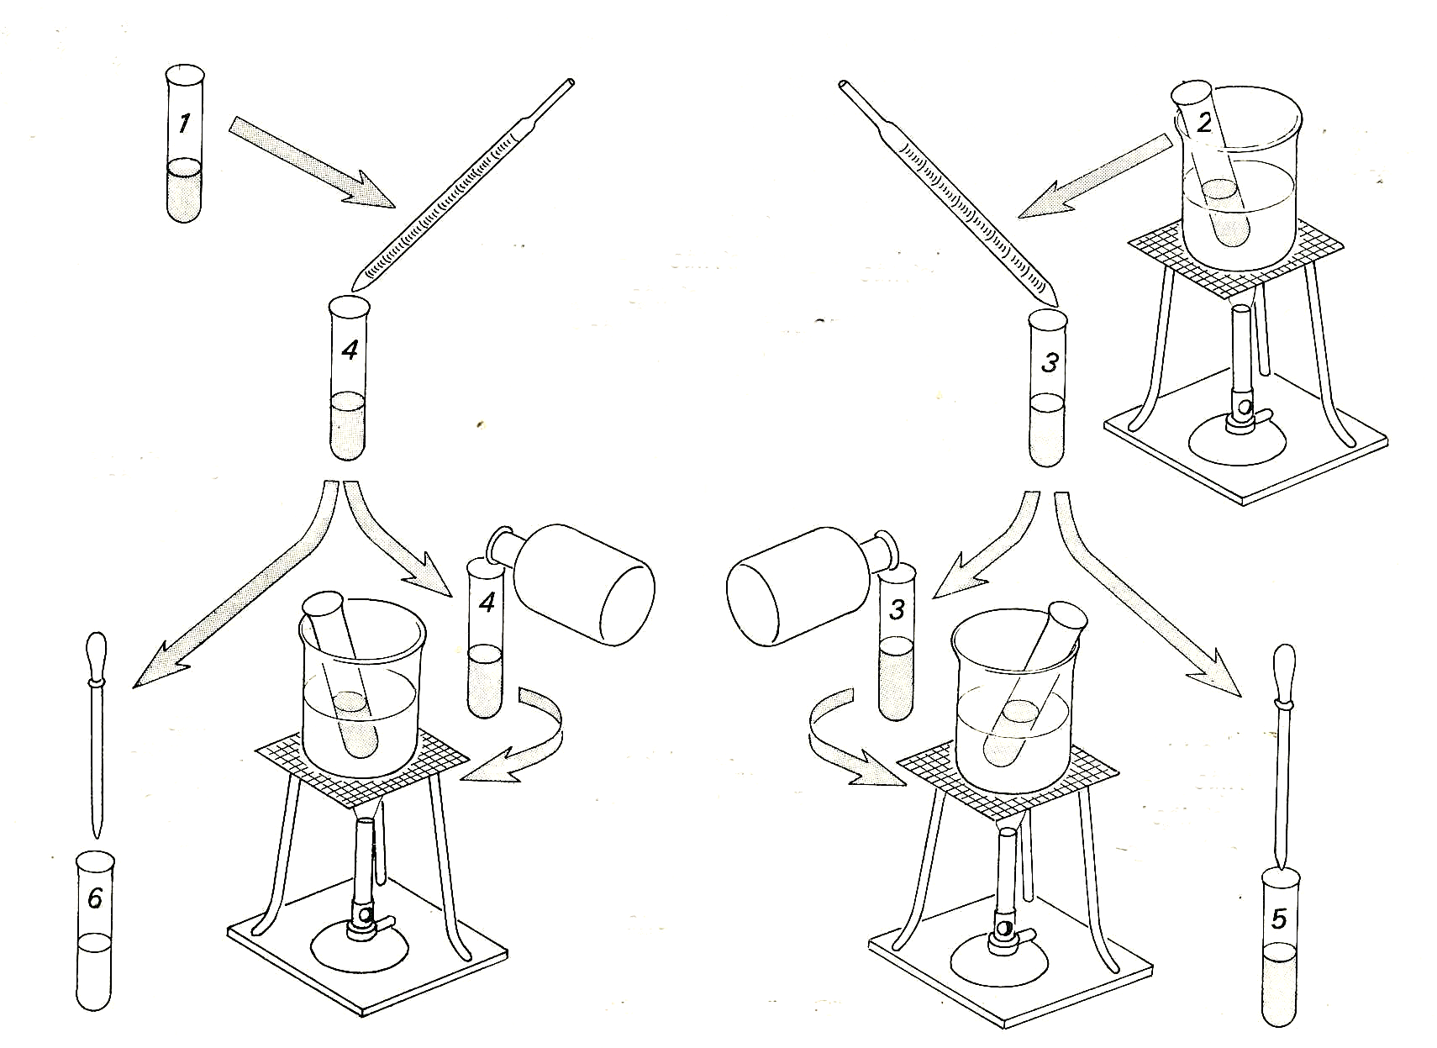

collect saliva and transfer half to tube 2
boil
saliva

add 5cm³
. unboiled ……saliva….. boiled
to
5cm³ starch solution
and leave for 5 mins

divide the contents equally

add 3
drops
iodine
solution
add 3 drops iodine solution
add 1 cm
Benedict’s solution

and boil

Experiment 9. The action of saliva on starch - preparation
Enzymes 9.03

NOTE The use of saliva in school experiments is not banned but certain precautions should be taken:
Students should work with only their own saliva
They should wash out their own glassware
The tubes should be sterilised in 1% sodium hypochlorite (sodium chlorate (1)) (See the ASE’s ‘Safeguards in the School Laboratory’ 11e p.95

Outline This is similar to ‘Enzymes’ experiment 1 but includes a control. It is shown that normal saliva will act on starch to produce sugar while boiled saliva will not..

Prior knowledge Starch/iodide reaction, Benedict's reaction.

Advance preparation and materials-per group

2% starch solution * (freshly prepared)
iodine solution 5 cm³
Benedict's solution 15 cm³

Apparatus-per group

test-tube rack and 8 test-tubes dropping pipette (if not part of iodine bottle)
8 labels or spirit marker graduated pipette or syringe (5 or 10cm³)
test-tube holder beaker (for rinsing pipette)
Bunsen burner

*See note on p. 8.03

Experiment 9. Discussion - answers
Enzymes 9.04

1 Iodine is a test for starch; Benedict's solution is a test for reducing sugars.

2 Tube 4 gives an orange precipitate with Benedict's solution and shows that sugar is present. Tube 6 fails to give a blue colour with iodine and thus shows that starch has gone.

3 In tubes 3 and 5, the only difference was that the saliva had been boiled.

4 (a) The results are consistent with the hypothesis that an enzyme in saliva changes starch to
sugar, but
(b) they do not prove it (see question 6).

5 If an enzyme in saliva was responsible for converting starch to sugar, boiling would denature the enzyme and prevent the reaction from taking place The failure of the starch to disappear in tube 5 and of sugar to appear in tube 3 thus supports the enzyme hypothesis.

6 The experimental results by themselves do not rule out these alternative interpretations, except
that it seems unlikely that starch would disappear if hypothesis (a) were correct.

7 The student might see that by breaking the starch molecule at the -O- linkages and adding
OH to one side and H to the other, glucose molecules would be formed. (The fact that it is
actually maltose that is produced is not considered of vital importance at this stage.)
By definition, an enzyme would catalyse the reaction in some way.

8 To hydrolyse 3% starch in experiment 8, 15 minutes at 100 °C was needed. With saliva, only
5 minutes at room temperature was needed.

