Experiment 11. The effect of pH on the reaction between pepsin and egg-white
Enzymes 11.01

(a) Label five test-tubes 1-5.

(b) Using a graduated pipette or syringe place 5 cm³ of egg-white suspension in each tube.

(c) Using a graduated pipette or syringe, add acid or alkali to the tubes as indicated in the table below.

(d) Prepare a water bath in a 250 cm³ beaker or jar by mixing hot and cold water from the tap to give a temperature of about 40ºC. Have the beaker half full.

(e) Using a graduated pipette or syringe, add 1 cm³ 1% pepsin solution to each tube.

(f) Place all five tubes in the water bath.

(g) Copy the table below into your notebook.

(h) After five minutes, return the tubes from the water bath to the test-tube rack and
compare the appearance of the contents.

(i) Compare the pH of each tube by taking a sample with a clean dropping pipette and touching the tip of the pipette on to a piece of pH test paper so that a small drop of liquid runs on to it. Compare the colour produced on the paper, with the standard chart supplied. Repeat this for each tube, rinsing the pipette between samples.

(j) Record your results in the table in your book.

Tube | Egg-white suspension and pepsin plus: | pH | Appearance of contents after 5 minutes
1 | 2 cm³ sodium carbonate solution
2 | 0.5 cm³ sodium carbonate solution
3 | Nothing
4 | 1 cm³ hydrochloric acid
5 | 2 cm³ hydrochloric acid

Experiment 11. Discussion
Enzymes 11.02

1 In the experiment, at what pH was the hydrolysis of egg-white most effective?

2 This pH is not necessarily the optimum (best) pH for the hydrolysis of egg-white by pepsin. Why not?

3 Can you determine from your results the pH least favourable to the reaction of pepsin
on egg-white? Explain.

4 Suggest ways in which the sodium carbonate and hydrochloric acid could influence the reaction between pepsin and egg-white apart from merely altering the pH.

5 Do you think that the pH in your stomach corresponds approximately to the pH in the experiment which resulted in the most rapid hydrolysis of egg-white? If not, why
not?

6 See if you can find out from a book what the pH in the human stomach really is.

7 Would you expect it to be the same in all people and at all times? Explain.
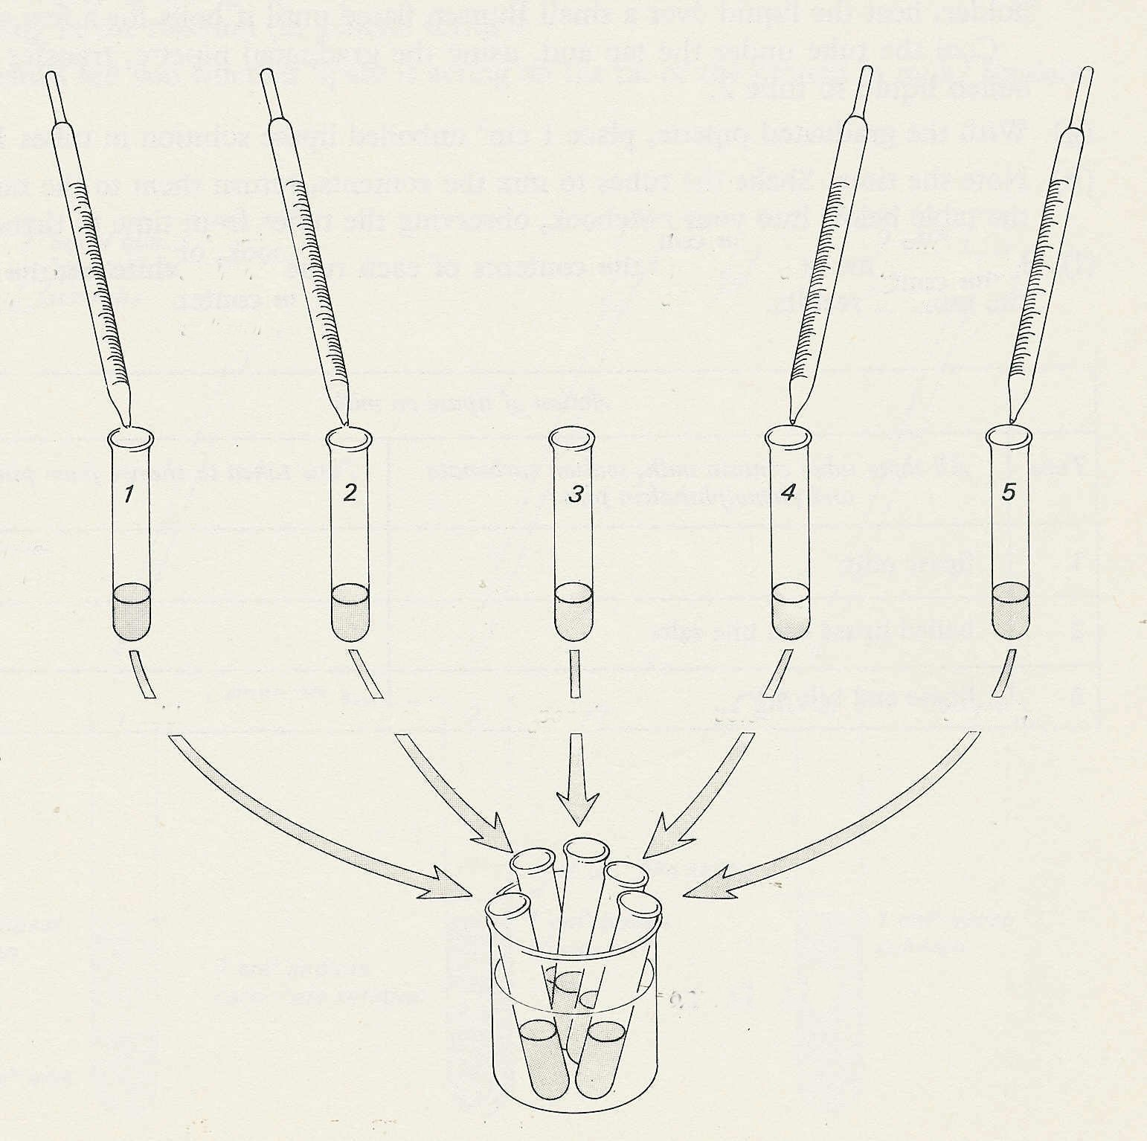

1 cm³
hydrochloric
acid
2 cm³
hydrochloric
acid

2 cm³
sodium carbonate solution
0.5 cm³
sodium carbonate solution

5 cm³ egg-white suspension
in each tube

add
1cm³
pepsin
solution
to each

approx 40° C

Experiment 11. The effect of pH on the reaction between pepsin and egg-white - preparation
Enzymes 11.03

Outline The rates at which a cloudy egg-white suspension goes clear are compared at different
pH values.

Prior knowledge Hydrolysis of egg-white by pepsin as in Experiment 10; use of indicators to
estimate acidity and alkalinity; idea of pH as a method of expressing degrees of acidity and
alkalinity.

Advance preparation and materials-per group

1 % egg-white suspension * 30 cm³ pH papers. Range 2-11 2 strips
0.1M hydrochloric acid 5 cm³ chart of standard colours (use transparent adhesive
0.05M sodium carbonate solution 5 cm³ tape to fix covers from books of pH papers to
1% pepsin solution 10 cm³ cardboard strips)

Apparatus-per group

test-tube rack and 5 test-tubes 250 cm³ beaker or jar
5 labels or spirit marker thermometer
graduated pipette or syringe 5-10 cm³ dropping pipette

* See Reagents for food tests and enzymes p. 01

Experiment 11. Discussion - answers

1 At pH 2-3 the egg-white suspension will probably clear most rapidly.

2 There may be little to distinguish between the results of pH 2 or 3 as far as rapidity of clearing
is concerned. The experiment would have to be slowed down by, for example, reducing
concentration of pepsin and then the intermediate pH values tested. The most acid atmosphere tested is likely to be the most effective; pH values of less than 2 have not been tried and might prove to be optimal.

3 Since none of the tubes 1-3 is likely to clear in about 20 minutes, it is not possible to determine
the least favourable pH. Perhaps any pH above pH 3 arrests the reaction completely or at least
makes it very slow.

4 The reagents hydrochloric acid and sodium carbonate might have reacted or combined with the egg white or the enzyme and a1tered their properties in a manner similar to that of specific
enzyme inhibitors.

5 Unless students already know the pH in the stomach, they might be reluctant to believe that the acidity is as much as pH 2. They may say that the acid would damage the tissues.

6 The pH of normal, fasting gastric juice is given as pH 1.0 to 1.5.

7 The pH of the stomach might be expected to vary slightly between individuals and to a more marked extent in connection with feeding. Drinking, for example, will dilute the stomach
contents; more hydrochloric acid might be secreted after a protein meal.

