Experiment 13. The action of starch phosphorylase
Enzymes 13.01

(a) Cut a piece of potato about 20 mm square and further cut it into small pieces. Place
these in a mortar with a little clean sand and grind them finely with a pestle.

(b) Using a graduated pipette or syringe, add 10 cm³ distilled water to the mixture and continue
grinding for a few seconds.

(c) Filter the extract through a fluted filter paper, into a clean test-tube.

(d) While you are waiting for the filtration, use a dropping pipette to place eight drops of
a 5% solution of glucose phosphate on a spotting tile, in two rows of four drops.

(e) Rinse the dropping pipette and use it to draw up some of the filtered potato extract.
Place one drop in a spare cavity in the tile and test it with a drop of iodine. If it goes blue, the extract will have to be filtered again.

(f) If the sample of filtrate does not give a blue colour when tested with iodine, place one drop of the extract on each drop of glucose phosphate in the top row.

(g) Using a test-tube holder, boil the remainder of the potato extract in the test-tube, over a small Bunsen flame; rinse the dropping pipette and use it to place a drop of the boiled extract on each drop of glucose phosphate in the bottom row. Note the time.

(h) Copy the table below into your notebook.

(i) After 5 minutes place four drops of dilute iodine on the first drop of the mixture in each row and record any colour change. At intervals of 5 minutes, repeat this test with the second, third and fourth drops in both rows.
From time to time add a drop or two of iodine to the samples already tested because the colours tend to fade.

(j) When the experiment is complete, use a spare cavity in the tile to test a sample of glucose phosphate with iodine.

 | Drops | Colour on adding iodine at 5 min intervals
 | Drops | 5 min | 10 min | 15 min | 20 min
Top row | Potato extract and glucose phosphate
Bottom Row | Boiled potato extract and glucose phosphate
Colour on adding iodine to glucose phosphate alone
Colour on adding iodine to filtered potato extract alone

Experiment 13. Discussion
Enzymes 13.02

1 Does the filtered potato extract contain any starch?

2 Does the glucose phosphate contain any starch?

3 How do you interpret the colour changes that occur when iodine is added to the mixture of glucose phosphate and potato extract?

4 Consider two possibilities:
(i) something in potato extract has converted glucose phosphate to starch.
(ii) the glucose phosphate has converted something in potato extract to starch.
(a) In view of the result& with the second row of drops, which of the two possibilities
is the more likely? Say why.
(b) Suggest a further control experiment that might help to support one of the two
alternatives.

5 Are your results consistent with the hypothesis that the potato extract contains an enzyme which converts glucose phosphate to starch?

6 Give a simple chemical explanation of how this change could come about assuming that the phosphate merely makes the glucose more reactive. (Consult the structural formulae
on p. 8.02.)

7 What part could such an enzyme play in the development of a potato tuber?
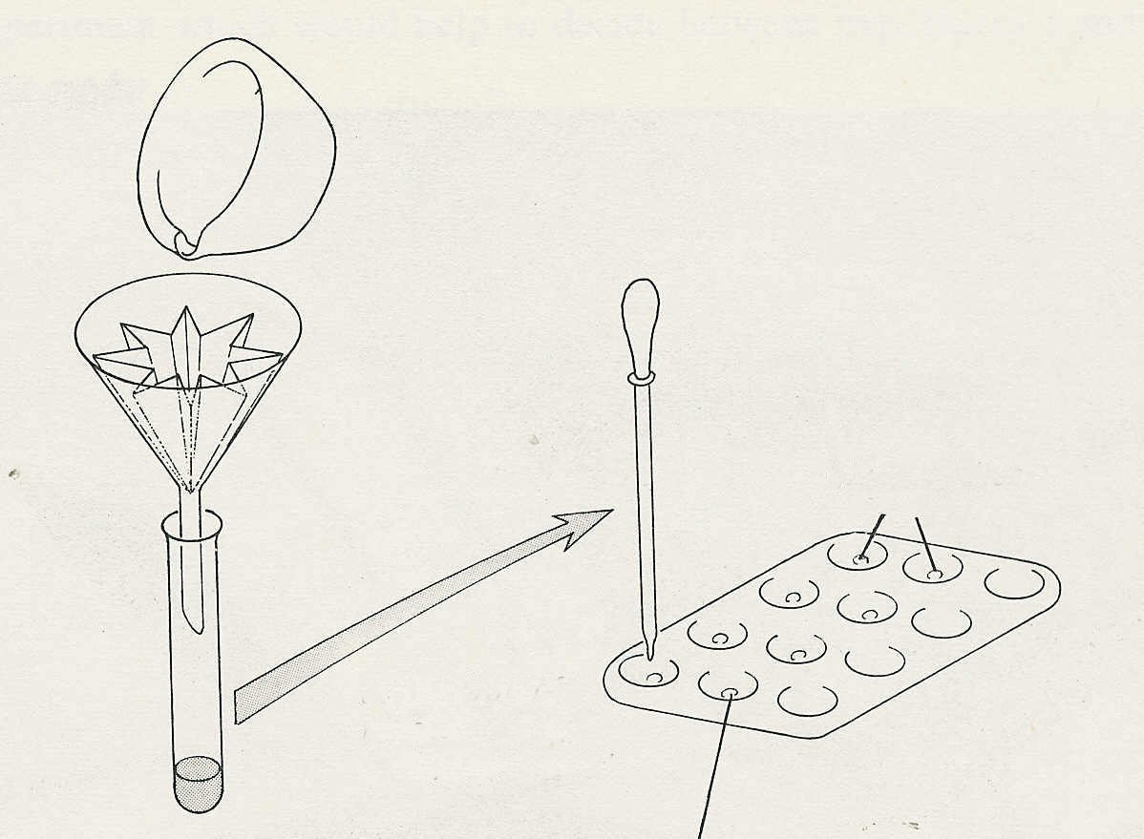
filter the potato extract
add one drop of filtrate to
each cavity in top row
glucose phosphate solution
add one drop of boiled filtrate to each cavity of bottom row

‘fluted’
filter
paper

Experiment 13. The action of starch phosphorylase
Enzymes 13.03

Outline Potato extract contains an enzyme, starch phosphorylase, which, in vitro at least, converts glucose-1-phosphate to starch. (In living cells, starch phosphorylase catalyses the reverse reaction). The experiment is an illustration of an enzyme catalysing a ‘building up’ reaction in contrast to the other experiments
After 15 minutes with potato extract, glucose-1-phosphate will give a blue colour with iodine showing the formation of starch.

Prior knowledge Starch/iodide reaction; enzymes; the effect of boiling on enzymes; how to fold a ‘fluted’ filter paper.

Advance preparation and materials-per group

potato 1 large one will be sufficient dilute iodine⁺ 5 cm³
for a whole class washed sand 2g
5% solution glucose-1-phosphate* 1 cm³ distilled water l0 cm³

Apparatus-per group

test-tube rack and 1 test-tube spotting tile
filter funnel dropping pipette
filter paper test-tube holder
mortar and pestle Bunsen burner
means of cutting potato safely

-per class

clock

* Glucose-1-phosphate is very expensive and it is better to make up the smallest possible volume in one container and have the students take the drops from this single source under supervision, than to give out 1 cm³ to each group.
A solution of 0.5 g in 10 cm³ distilled water will be enough for 20 experiments. The solution will not keep but the crystals will, if kept in a refrigerator.

⁺ See ‘Reagents for food test and enzymes’ p.01

Experiment 13. Discussion - answers
Enzymes 13.04

1 There should be no blue colour if the potato extract has been properly filtered.

2 Glucose-1-phosphate gives no blue colour with iodine.

3 Colours may range from mauve to blue and suggest the progressive accumulation of starch.

4 (a) Alternative (i) is more likely since boiling the potato extract prevented the formation of
starch.
(b) If the glucose-1-phosphate were boiled and still found to react with potato extract to form
starch, this would be additional evidence.

5 The results are consistent with this hypothesis.

6 Glucose molecules have been joined together in a long chain, so forming a starch molecule.

7 Soluble sugars, made in the leaves, travel via the phloem to reach the tuber. Enzymes in the tuber convert the sugars to insoluble starch, which is more readily stored.
In certain conditions, starch phosphorylase may catalyse the reverse reaction, i.e. the hydrolysis
of starch.

