Experiment 14. Dehydrogenase in yeast
Enzymes 14.01

During respiration, hydrogen atoms are removed from glucose molecules by enzymes
called dehydrogenases and passed to various chemicals called hydrogen acceptors. As the hydrogen atoms pass from one hydrogen acceptor to another, energy is made available for
chemical reactions in the cell. In this way, substances such as glucose provide energy for vital reactions in living organisms.
In this experiment, a dye called methylene blue acts as an artificial hydrogen acceptor. When this dye is reduced by accepting hydrogen atoms it goes colourless.

(a) Place about 30 mm of yeast suspension in a test-tube and, using a test-tube holder, heat
this suspension over a small Bunsen flame until the liquid boils for about half a minute.
Then cool the tube under the tap.

(b) Label three test-tubes 1-3.

(c) Using a graduated pipette or syringe, place 2 cm³ of the boiled yeast suspension in tube 1.

(d) Using the graduated pipette or syringe, draw up 4 cm³ unboiled yeast suspension and place
2 cm³ in tube 2 and 2 cm³ in tube 3.

(e) Rinse the pipette or syringe and use it to place 2 cm³ distilled water in tubes 1 and 2.

(f) With the pipette or syringe, place 2 cm³ 1 % glucose solution in tube 3.

(g) Prepare a water bath by mixing hot and cold water from the tap to obtain a temperature
between 35 and 45 °C. Place all three tubes in this water bath. Rinse the pipette or syringe.

(h) Copy the table given below into your notebook.

(i) After 5 minutes draw up 6 cm³ methylene blue solution in the pipette or syringe and place
2 cm³ in each tube. Shake all three tubes thoroughly and return them to the water bath, noting the time as you do so. Do not shake the tubes again.

(j) Watch the tubes to see how long it takes for the blue colour to disappear, leaving the
creamy colour of the yeast. A thin film of blue colour at the surface of the tube may
be ignored but the tubes should not be moved. Record the times in your table.

(k) The experiment may be repeated by simply shaking all the tubes again until the blue
colour returns.

Tube | Contents | Time for methylene blue to go colourless
1 | Boiled yeast
2 | Unboiled yeast
3 | Unboiled yeast + 1% glucose

Experiment 14. Discussion
Enzymes 14.02

1 Why was distilled water added to tubes 1 and 2?

2 What causes the methylene blue solution to go colourless (according to the introduction
on p. 14.01)?

3 How do you explain the results with tube 1?

4 In which of tubes 2 and 3 was the methylene blue decolourized more rapidly? How can
this result be explained?

5 If the hydrogen atoms for the reduction of methylene blue come from glucose, why should the methylene blue in tube 2 become decolourized at all?

6 What do you think would be the effect of increasing the glucose concentration in tube 3? Explain your answer.

7 How could you extend the experiment to see if enzymes in yeast are capable of reducing
methylene blue?

8 Why, do you think, the colour retuned on shaking the tubes?

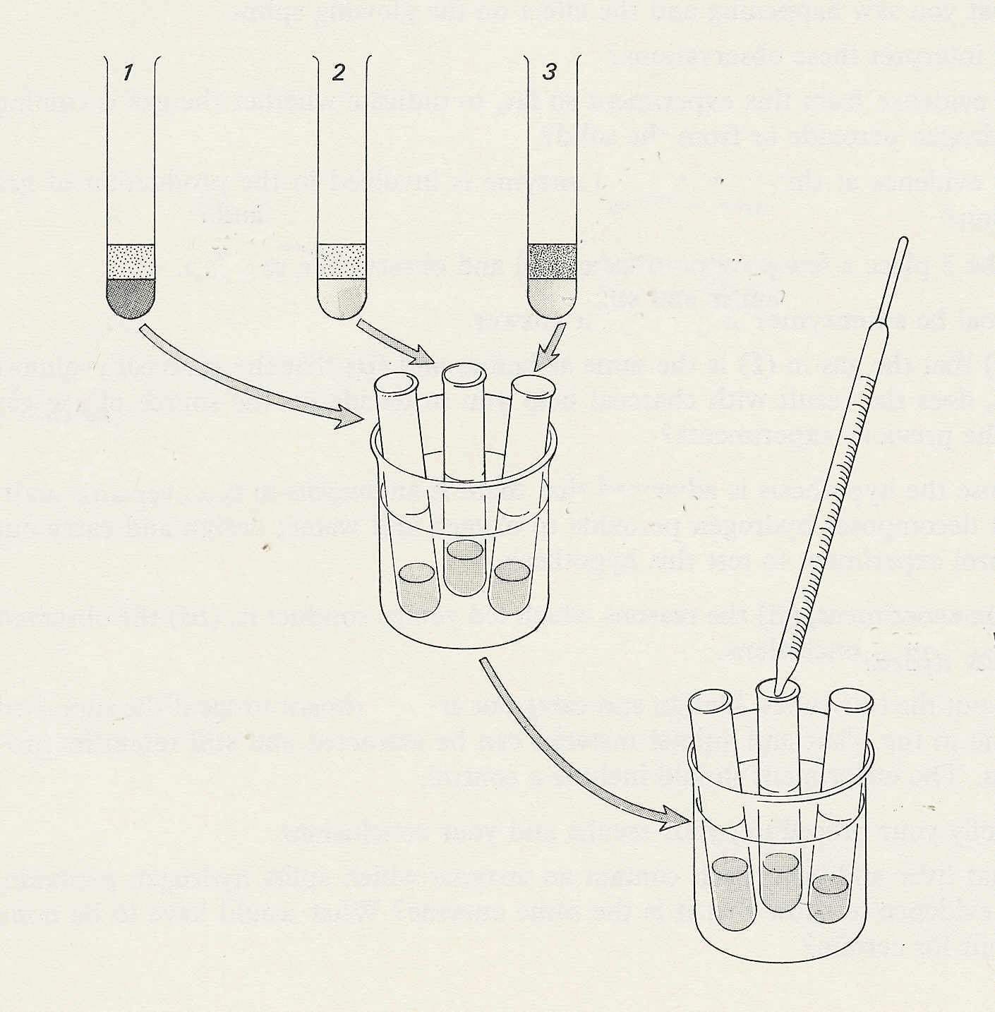

2 cm³
distilled
water
2 cm³ glucose solution

2 cm³ unboiled yeast suspension in 2 and 3

2 cm³ boiled yeast suspension in 1

about 40°C

2 cm³ methylene blue in each tube

leave 5 mins

Experiment 14. Dehydrogenase in yeast - preparation
Enzymes 14.03

Outline Methylene blue, acting as a hydrogen acceptor, is decolourized during the respiration of
yeast. Addition of small amounts of substrate increases the rate of decolourization.

Prior knowledge An elementary idea of respiration as a process which releases energy during
the breaking down of carbohydrates; yeast is a microscopic living organism.

Advance preparation and materials-per group

20% yeast suspension* 0.005% methylene blue solution⁺
(prepared 1~2 days ahead) 10 cm³ 1 % glucose solution
distilled water 10 cm³

Apparatus-per group

test-tube rack and 4 test-tubes Bunsen burner
3 labels or spirit marker graduated pipette or syringe 5-10cm³
test-tube holder beaker or jar, for water to rinse pipette or syringe

-per class

clock

Result The methylene blue: in tubes 2 and 3 should be decolourized in a few minutes with tube 3 changing first.

* Add 40 g dried yeast and 0.4 g potassium dihydrogen phosphate (KH₂PO₄) to 200 cm³ distilled water in a tall 600 cm³ (or larger) beaker (a large jam jar will do). Cover the mouth of the container with aluminium foil and bubble air through the yeast suspension for one or two days using an aquarium aerator. Observe the suspension from time to time during the first two hours and control the air flow to prevent the yeast suspension frothing out of the jar.

⁺Dissolve 0.05 g in 1 litre of distilled water. Methylene blue stains skin and clothing. Lab coats should be worn

Experiment 14. Discussion - answers
Enzymes 14.04

1 The addition of distilled water to tubes 1 and 2 keeps the concentration of yeast and methylene blue the same in all three tubes.

2 The methylene blue accepts hydrogen atoms removed from glucose molecules during respiration. The reduced form of methylene blue is colourless.

3 Boiling will have killed the yeast. Dead yeast is therefore incapable of carrying out one or more stages in the transfer of hydrogen from glucose to methylene blue. (A similar answer may be given in terms of enzymes.)

4 Tube 3 will probably lose its blue colour first. Presumably if the hydrogen atoms for reducing methylene blue come from glucose, additional glucose will mean that more hydrogen atoms are available and decolourization will be more rapid.

5 Respiration will continue in yeast cells, using their own carbohydrate reserves such as glycogen.

6 It might be expected that increasing the glucose concentration would increase the rate of
decolourization up to the point where all the available enzyme or enzymes were being used, or where the concentration of glucose was sufficient to plasmolyse the yeast cells.

7 If enzymes (dehydrogenases) are involved, it should be possible to extract them from yeast by
grinding some dried yeast with sand and distilled water, and filtering. This could be the subject
of further experiment, particularly if little or none of the carbohydrate reserve in yeast comes through in the filtrate.

8 Shaking the tubes introduces more oxygen which re-oxidises the methylene blue

