Experiment 14. Vital capacity and tidal volume
Respiration 14.01

Vital capacity

(a) Put water in the bowl to a depth of about 50 mm. Fill the container with water from the tap
and put on the lid or stopper.

(b) Hold the container upside down in the bowl, with the lid or stopper under the water. Remove the stopper under water without letting air in. Some water will escape if the container is made
of plastic but this does not matter.

(c) Push a length of rubber tubing through the mouth of the container to position A (See Figure on p. 14.02). Take a deep breath and blow through the tube until you can exhale no more.

(d) All the air you have breathed out will collect in the container and by comparing the water level inside with the graduations marked on the container you will obtain an approximate measure of the maximum volume of air which your lungs can breathe in and out. This is called your vital capacity.

(e) If you intend to repeat the experiment, you must remove enough water from the basin to
restore the level to the 50 mm mark.

Tidal volume

(f) When you have measured your vital capacity, leave the air in the container and the bowl nearly full of water but push the rubber tubing further through the neck of the container until it is
above the water level inside, position B (See Fig.).

(g) Blow through the tube just enough to clear out any water trapped in it and raise or lower the container until the water level inside and outside is the same and at a convenient mark, e.g. the
4 or 3.5 litre mark.

(h) Place the end of the rubber tubing in your mouth and breathe in and out a few times as normally as possible, holding the container and allowing it to move up and down in the bowl so that the water levels inside and outside remain the same.

(i) By watching the graduations on the side, you will be able to see approximately how much air you exchange when you breathe normally. This is called the tidal volume.

(j) If a second person is to use the apparatus, the rubber tubing should be rinsed in disinfectant
and washed under the tap.

Experiment 14. Discussion
Respiration 14.02

1 What results did you get for (a) vital capacity, (b) tidal volume?

2 Why do you think the vital capacity is so much greater than the tidal volume, i.e. if you need to exchange only a few hundred cubic centimetres of air in breathing, what is the advantage of having a lung capacity of several litres?

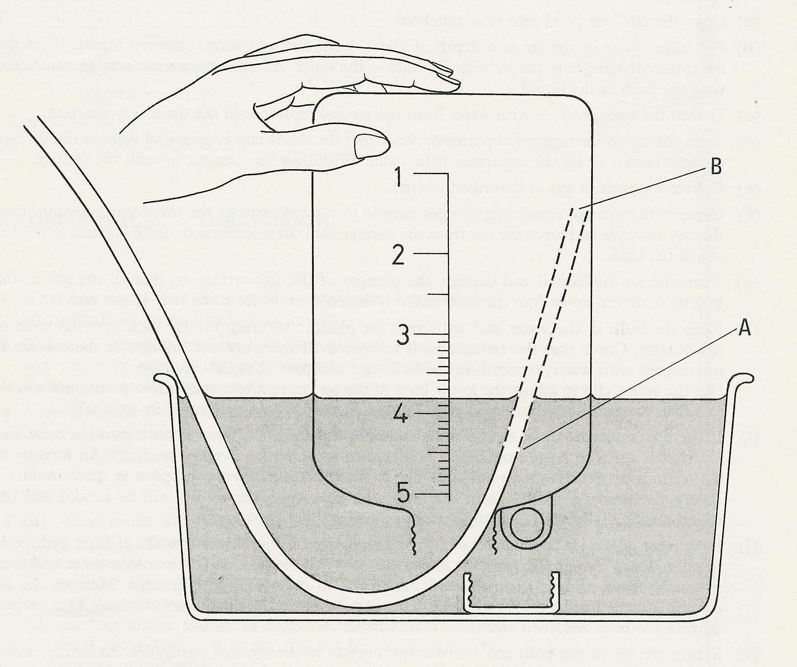

Respiration 14.03

Experiment 14. Vital capacity and tidal volume - preparation

Outline The student blows air into an inverted, graduated container filled with water.

Prior knowledge None.

Advance preparation and materials - Provide one of the following for each group:

Bowl. The bowl needs to be not less than about 35 cm (14 in) wide and 12.5 cm (5 in) deep. If it
is smaller than this, the water expelled from the container may overflow. It is advisable
to check that the bowl will hold 5 1itres of water in addition to that needed to provide a
starting depth of 50 mm and in any case it is best to conduct the experiment near a sink if
possible.
Use a spirit marker to indicate the 50 mm level on the inside of the bowl.

Container. The large plastic bottles for holding concentrated fruit drinks etc. have a capacity of
over 4.5 litres.* Graduate the container by pouring in 500 cm³ volumes of water from a
measuring cylinder and marking the wall with a spirit marker. Between the 3 and 5 litre marks,
calibrate in 100 cm³.

Rubber tubing. 50 cm of 6.5 mm bore, 1.5 mm wall. The tubing used for experiment 3 will do.
Before the tubing is used for a second experiment it should be rinsed in disinfectant⁺, and
washed with running water from the tap.

NOTE. If the class results for vital capacity are collected, they can be used to look for correlations with sex, age, size (weight), chest expansion etc.

*The vital capacity of some adolescent boys is likely to approach or exceed 4.5 litres.

⁺An ampholyte disinfectant at 1:100 dilution is recommended, e.g. Harris B.A.S.

Experiment 14. Discussion - answers

1 The vital capacity will range, probably, from 2.5-4.5 litres. The tidal volume should be between 200 and 500 cm³.

2 Although only up to 500 cm³ air is exchanged during quiet breathing, increased activity results in increased frequency and depth of breathing. The increased demands for oxygen in the body are thus met. If the vital capacity were the same as the tidal volume there would be less ability to cope with such rising demands.

