Experiment 17. The response of shoots to unilateral gravity
Germination 17.01

You are provided with two bean seedlings with straight hypocotyls.

(a) Place the seedlings in turn alongside a ruler, measure the length of the shoot (Fig. 1) and record this length in your notebook.

(b) Use a spirit marker to put lines or dots on the hypocotyl and stem at 2 or 3 mm intervals,
starting from the extreme tip. Count the number of marks on each stem and record this in your notebook.

(c) Fill two test-tubes with water. Wrap cotton wool round the base of the hypocotyl of each
seedling and insert them in the mouths of the test-tubes with the root system fully immersed
in water. The cotton wool should hold the seedling firmly in place and not let any water out when the tube is held horizontally. Mark each tube with your initials.

(d) Place one of the test-tubes on its side in the rack provided so that the shoot is horizontal and clear of the bench top (Fig. 2a).

(e) Place the other tube in one of the clips on the clinostat (Fig. 2b) so that the shoot is horizontal.
The clinostat will be set to rotate with the seedlings held horizontally. Leave both seedlings for
4-24 hours or more in a part of the laboratory which receives little or no direct light.
Alternatively screen the experiments from strong light sources.

(f) After a period of 4 hours or more, examine each shoot and note (i) any change in its direction
of growth, (ii) whereabouts in the stem this has occurred and (iii) the spacing of the marks
on the stem.

(g) Measure each shoot and record its length in your notebook. Make simple outline drawings of
each of the two shoots.
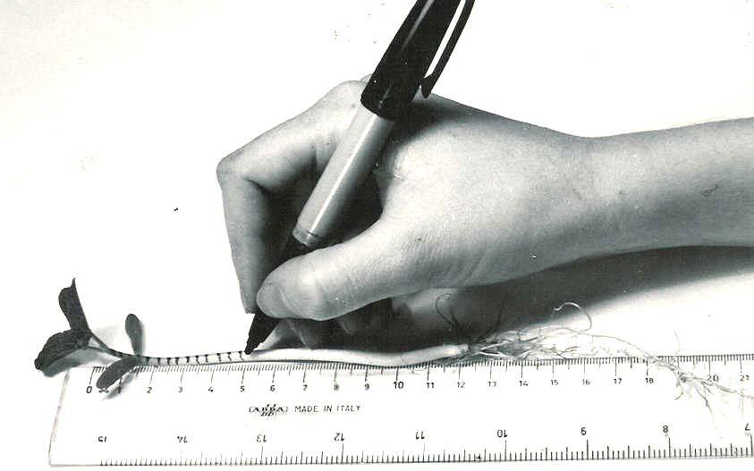

Fig. 1
Experiment 17. Discussion
Germination 17.02

1 Had the shoots increased in length? If so, by how much? Where, according to the marks on the
stem, had most growth occurred?

2 Had the shoots changed their direction of growth, continued to grow horizontally, or had they not grown at all?

3 In what direction was gravity acting with respect to the shoots in (a) the stationary tubes,
(b) the rotated seedlings*?

4 If either of the shoots had changed its direction of growth, in what way was this related to the
direction of gravity?

5 If a change in direction had occurred, (a) was the curvature confined to the region which had
appeared since you set up the experiment or (b) had it taken place in a region you had marked;
(c) was it restricted to the region in which maximum growth had occurred?

6 Assuming that the class results as a whole suggest a relationship between the direction of gravity and the growth of a shoot, what advantage might this have in the normal germination of a seed?

7 Do all of the growing shoots of a flowering plant respond to gravity in the same way? Give one or two examples.

8 Why are the seedlings on the clinostat considered as controls in this experiment?

* ‘Downwards' is not a satisfactory answer since it does not describe the direction in relation to the position of the plant, i.e. gravity will always act downwards whether the plant is upright or horizontal, stationary or rotating.

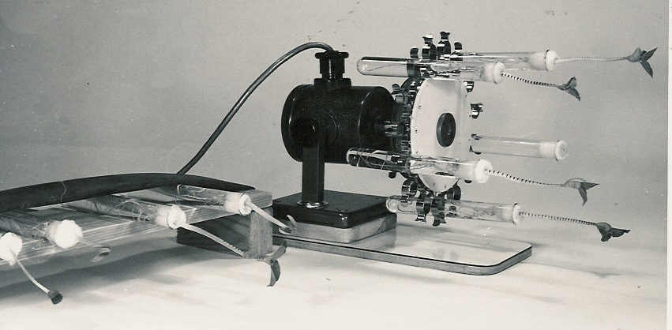

Fig. 2a Rack
Fig.2b Clinostat

Experiment 17. The response of shoots to unilateral gravity - preparation
Germination 17.03

Outline The hypocotyls and/or stems of bean seedlings are marked with equidistant dots and left
on their sides for 24 hours. A control is set up with a clinostat.

Prior knowledge Meaning of ‘clinostat’ and 'hypocotyl'.

Advance preparation and materials

Seedlings. Twelve to fourteen days before the experiment, soak the French beans overnight and
on the following day roll them up in moist blotting paper or newspaper with the radicles
directed downwards as described on p.2.02. Place the rolls in plastic bags and leave them
upright. Examine the seedlings after 8 or 9 days and when the hypocotyls start elongating
rearrange the seedlings so that the shoots are clear of the paper roll and exposed to uniform
illumination. The age of the seedlings is not critical for this experiment. Allow 2 seedlings
per group but sow twice as many seeds to compensate for germination failures. (50 French
beans weigh about 25 g.)

Clinostat. The clinostat can be modified to hold 15 test-tubes as shown on p 17.04*. A piece of
wood about 15 mm thick is cut to a circle of 13 cm diameter which will take 15 Terry clips
(size No.2 for 19 mm test-tubes) round its circumference. The clinostat may need raising and
mounting on a larger board to stop it falling forwards when loaded. Number the clips round the
wooden disc so that the students can identify their seedlings and check that it is loaded evenly,
e.g. 1-6-11 or 1-4-7-10-13, balancing it with test-tubes of water if necessary. Check that the
turntable rotates freely and that none of the test-tubes obstructs the movement.

Rack. The rack illustrated below is made from chip-board and a bicycle inner tube. It holds
the test-tubes horizontally and securely and is still portable.

Cotton wool. Prepare strips of cotton wool 160 x 20 mm cut from half the thickness supplied on
the roll, to wrap round the beans and hold them in the test-tubes.

Apparatus-per group -per class
2 test-tubes ruler with millimetres clinostat (modified)
spirit marker rack for test-tubes

NOTE. (a) The French beans will give discernible results in 3-5 hours but come to no harm if
left for several days. Check the water level, however, if the experiment is1eft for a
number of days.
(b) If a clinostat is not available or cannot be converted, leave the control seedlings
vertically in a test-tube rack and modify the discussion questions accordingly.

* A modified turntable may be purchased from Philip Harris

Experiment 17. Discussion - answers
Germination 17.04

NOTE. The answers here apply to the French bean.

1 The student's description of the region of growth will depend on the age of the seedling and the duration of the experiment. French bean seedlings, 2 weeks old, will not exhibit discernible
elongation for l or 2 days after marking the shoots; The first indications of elongation will be in
the terminal 50 mm of the hypocotyl.

2 The stationary seedlings will have shoots which have turned through 90° and are all growing
vertically upwards. The shoots on the clinostat will still be growing more or less horizontally.

3 (a) Gravity was acting consistently at 90° to the original direction of growth of the shoot.
(b) Gravity was acting at 90° to these shoots also but not consistently towards any one side
since the seedlings were rotating.

4 The stationary shoots had grown away from, and at l80° to the direction in which gravity was
acting.

5 The answers will depend on the age of the seedling and the duration of the experiment, but generally speaking the curvature appears in a marked region 50 mm or more below the plumule and not in the stem which has been added since the experiment was started. The curvature also occurs below the region of maximums elongation in a region which is not obviously increasing in length.

6 By growing upwards, away from gravity, the shoot will bring its leaves to a position likely to
receive light and air, and its flowers to a situation likely to be visible to passing insects.

7 Lateral shoots are not vertical, at least near the main stem; rhizomes, stolons and runners
grow horizontally.

8 Gravity cannot be eliminated, but its direction can be counteracted by rotating the seedlings.
When there is no consistent direction of gravitational force the shoots do not change their direction of growth, i.e. seedlings are affected not so much by gravity itself as by its direction.
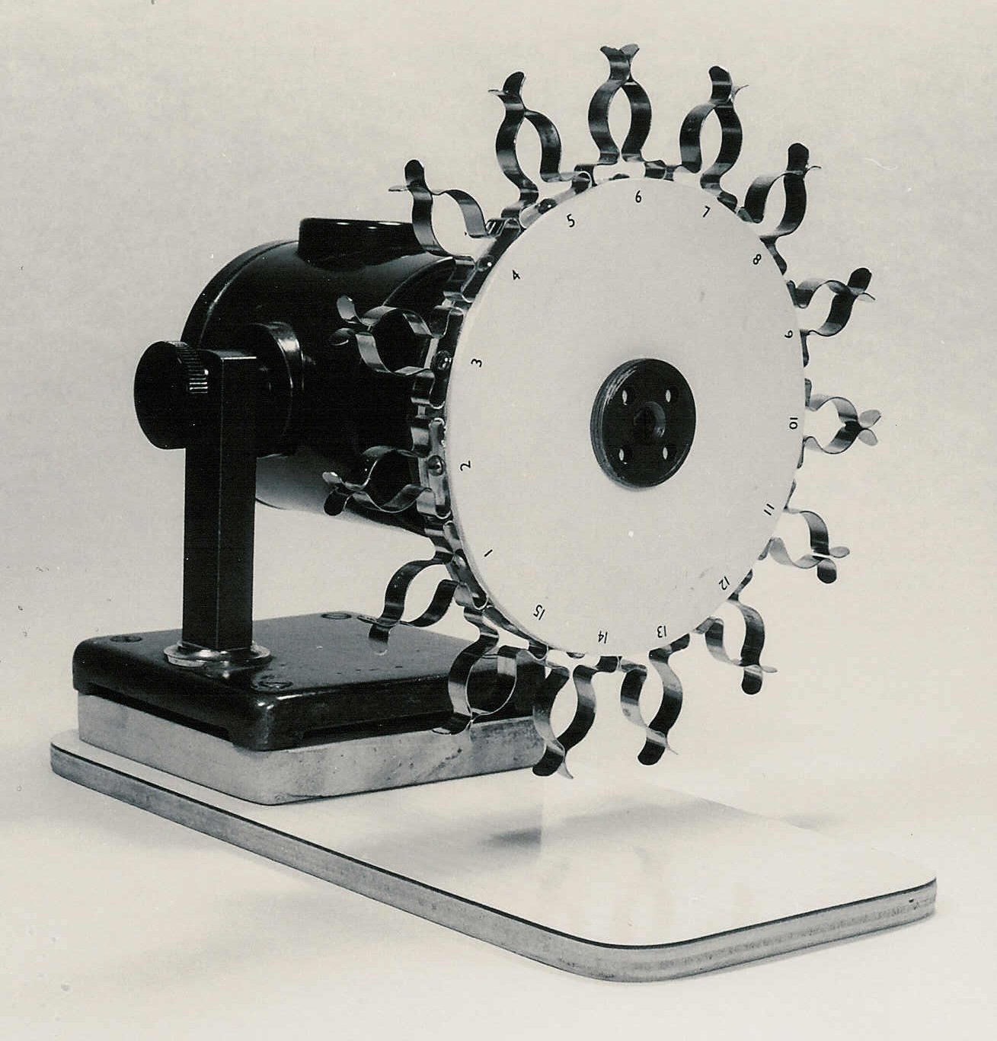
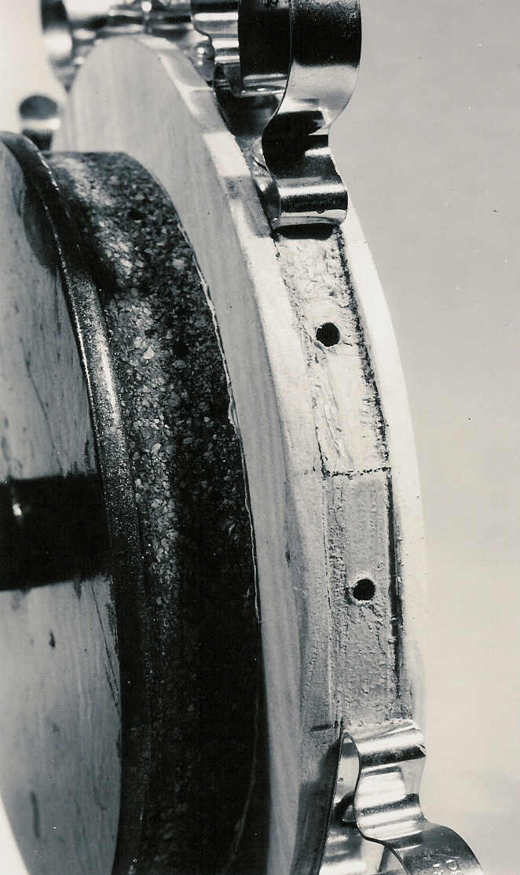
Flattened recesses for ‘Terry clips’
Modified clinostat
bolted to turntable
base raised and extended

