Experiment 10. Conditions affecting the production of oxygen
Photosynthesis 10.01

(a) Fill a large beaker or jar with tap-water up to the mark.

(b) Fit a clamp stand with a ring, gauze and clamp as shown in Fig. 2 so that the beaker is on a level with the bulb in a bench lamp.

(c) Use the clamp to grip the stem of the burette with the bulb clear of the water.

(d) Collect 3 or 4 pieces of pond-weed, 5-10cm long, and cut the ends with a razor blade mid-way between two nodes. Place the shoots upside down in the beaker, switch on the lamp to be used for the experiment and place it about 15 cm from the beaker. When bubbles appear from
the stems, select a shoot which is bubbling rapidly and regularly, and return the rest.

(e) Push the last node of the selected shoot into the hole at the base of the burette so that it is held upside down and lightly inside the bulb by the leaves (Fig. 1). It may be necessary to cut away part of the leaves in order to achieve this.

(f) Lower the burette so that the pond-weed and tip of the burette are immersed in water (Fig. 3).

(g) Withdraw the plunger of the syringe to fill the burette with water. Fit the screw clip obliquely (Fig. 4) over the rubber tubing to enclose as great a length of rubber as possible and screw it half shut.

(h) When the pond-weed is bubbling steadily, withdraw the syringe plunger carefully to draw out the air which has collected in the bulb, into the stem. Note the time or start the seconds timer.

(i) After a convenient period of time, e.g. 1, 2 or 3 minutes, withdraw the syringe plunger again to pull the collected gas into the stem of the burette where it can be measured. Use the screw clip to move the column to a convenient point for measuring the gas column

(j) By leaving the pond-weed to bubble for equal periods and withdrawing the syringe plunger, successive volumes of gas can be drawn into the graduated stem and the readings averaged.

(k) To start a fresh series of readings, all the gas bubbles can be removed from the bulb and the
stem by withdrawing the syringe plunger as in (g).

(l) You are now ready to compare the volumes of gas produced in different conditions as described in experiments 10 a-c.
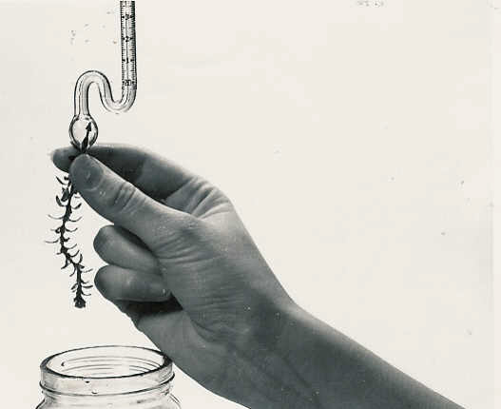

Fig 1 Push the last node through the hole in the bulb

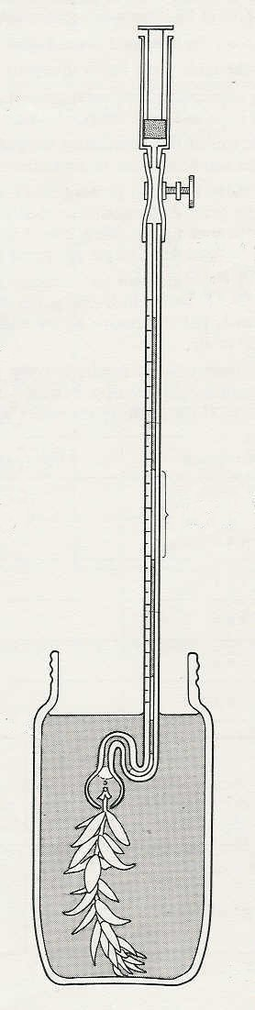
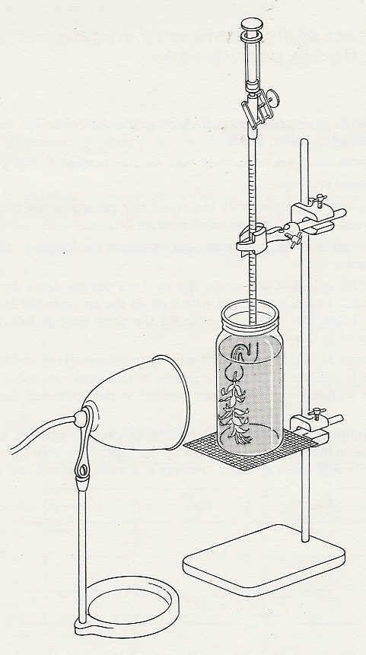
Photosynthesis 10.02

unscrew the
clip to draw gas from the bulb into the stem

measure the gas column

Fig. 2

gas collecting

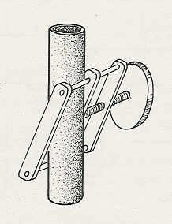

fit the screw clip obliquely over the rubber tubing

Fig. 4
Fig. 3

Photosynthesis 10.03

Experiment 10. Conditions affecting production of oxygen

Outline The experiment instructs the student in the setting up and use of a microburette to
measure the volume of gas produced by Elodea. Experiments 10 a-c use the same technique but
in varying conditions.

Prior knowledge A fair degree of manipulative skill. The meaning of the term 'node'.

Advance preparation and materials-per group

Elodea shoot about 80 mm long. Collect the Elodea before the experiment and keep it in the
light in fresh tap-water,
Microburette.* (See illustrations on p.10.04). Cut a piece of capillary tubing 6 mm diameter,
1 mm bore, 300 mm long, and flame polish one end. Soften the glass about 90 mm from the other end and bend it into a 'swan neck' as shown on p. 10.04. When the glass is firm, soften an area about 15 mm below the 'swan neck', pull the spare glass away and round off the pointed end in the flame without allowing it to thicken too much. Blow a bulb 6-10 mm in diameter at the sealed end. Make a hole in the bulb by heating a very small area at its base and blowing hard down the tube. If the hole is too small, replace it in the flame momentarily.
To make the scale, select a sheet of graph paper with clear black lines, preferably with a 2mm grid. Cut a 160mm strip, about 8mm wide. Rule strong lines every 10 squares and add the numerals 1 - 8 on the right. Use a clear glue to fix the scale to the capillary, starting about 20mm above the water line and with the numerals protruding on the right.
Fix a 60 mm length of 3 mm inside diameter pressure tubing to the stem. Fit a 2 cm³ plastic syringe to the rubber tube. Fit a 30 mm screw clip over the rubber tubing as shown on p. 10.02.
Before use, it is advisable to run some liquid detergent through the burette, followed by clean water to prevent the bubbles sticking to the sides of the bulb.

Apparatus-per group

microburette (have some spares in case weed stem breaks inside bulb)
600 cm³ tall beaker or tall jar, e.g. 200 g coffee jar, with a line marked at the 400 or 500 cm³ level
clamp stand gauze
clamp and boss head razor blade
ring, 120 mm in diameter bench lamp, 60 watt

-per class

clock with second hand or several seconds timers

NOTE. If carbon dioxide is deficient in the water it may be necessary to add from 1-5 cm³ 10%
sodium hydrogencarbonate solution to each jar of water.
It is assumed that although the gas is produced in the leaves of Elodea, the inverted shoots and cut stems offer an easy route for escape of the gas via the intercellular air spaces.

*A microburette based on this design may be obtained from Philip Harris

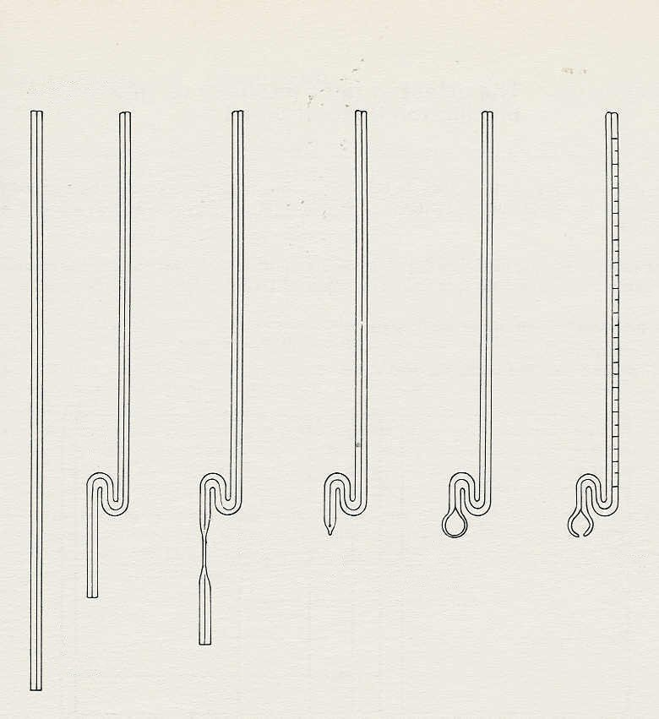
Photosynthesis 10.04
flame polish

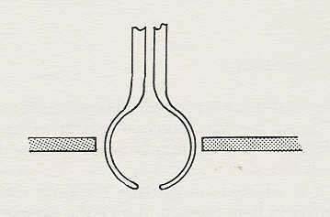
bend
soften
pull
seal
blow bulb
blow hole
It is worth making a template to check the diameter of the bulb
making the scale
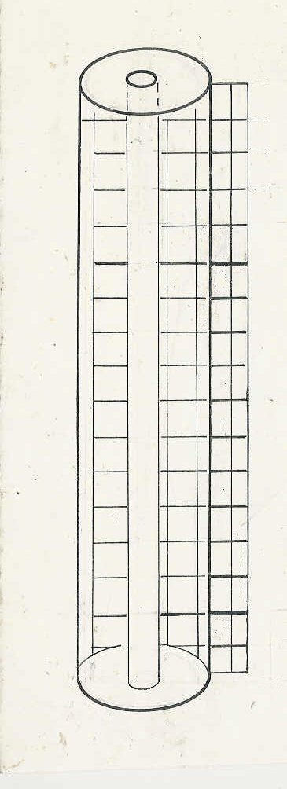
6
5

