Experiment 10 a. The effect of light intensity on gas production in pond-weed
Photosynthesis 10a.01

(a) Set up the pond-weed and gas burette as described on pages 10.01 and 10.02. Arrange the clamp stand at one end of a sheet of paper graduated as shown in Fig. 1.

(b) Switch on the lamp and place it with the mark on its base over the line marked I.

(c) Copy the table given below into your notebook.

(d) At an appropriate time, withdraw the syringe plunger carefully, to remove any gas which has collected in the bulb and leave the pond-weed to bubble for an exact number of minutes.

(e) At the end of this time, draw the gas into the graduated stem, measure the length of the gas
column and record this in your table.

(f) Now move the lamp to position 2xI and force the gas from the stem into the bulb. At a suitable moment, note the time and withdraw all the air from the bulb. Leave the weed to bubble for the same time as before and measure the volume of gas produced in this time.

(g) Repeat the experiment for distances 3xI, 4xI, 5xI and 6xI. It may be necessary (i) to reduce the time period over which the gas is collected if more accumulates than can conveniently be
measured, (ii) to remove air by withdrawing the syringe plunger if the apparatus becomes
too full of air.

(h) When your table of results is complete, plot a graph of volume of gas produced in a fixed time against light intensity, bearing in mind that the distances on the paper have been calculated
so that at 2xI the intensity is twice that at 1 and at 3xI the intensity is 3 times that at I and so on.

Light intensity | Volume of gas | Time | Volume per minute
I
2xI
3xI
4xI
5xI
6xI

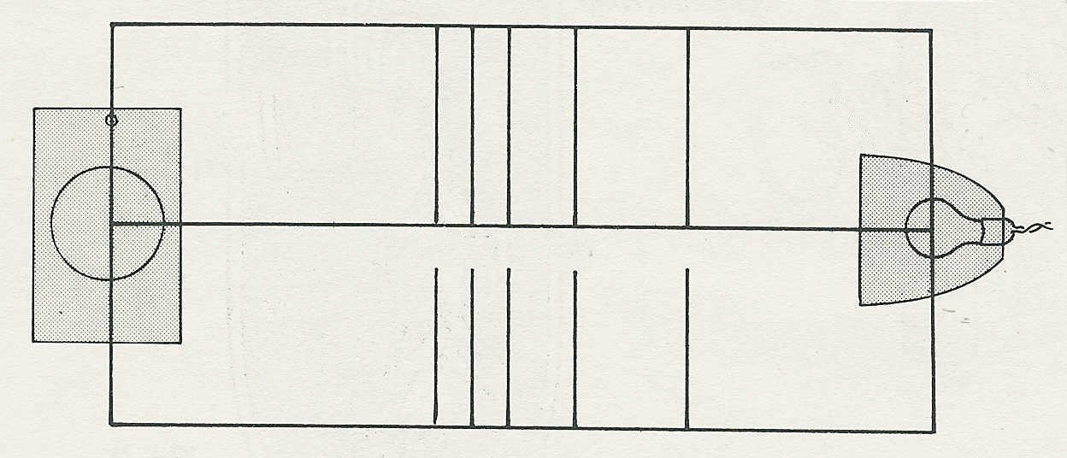
clamp stand and beaker
bench lamp

6xI
5xI
4xI
3xI
2xI

I

Fig. 1

Experiment 10a. Discussion
Photosynthesis 10a.02

1 What general effect did increasing light intensity have on gas production?

2 How could you explain the result in terms of photosynthesis?

3 In this experiment why is the rate of gas production not necessarily related to the rate of
photosynthesis?

4 What additional information would you need before you could assume that a doubling of gas
production also meant a doubling in the rate of photosynthesis?

5 In this experiment, the light intensity was progressively increased in equal steps throughout. Did the production of gas also increase in equal steps over the whole range of light intensities?

6 If the light intensity continued to increase beyond the range of your experiment, would you expect the gas production to continue increasing in proportion? Explain your answer.

7 What condition other than light intensity might have been altered inadvertently during the
course of this experiment? How would you expect changes in this condition to affect the results?

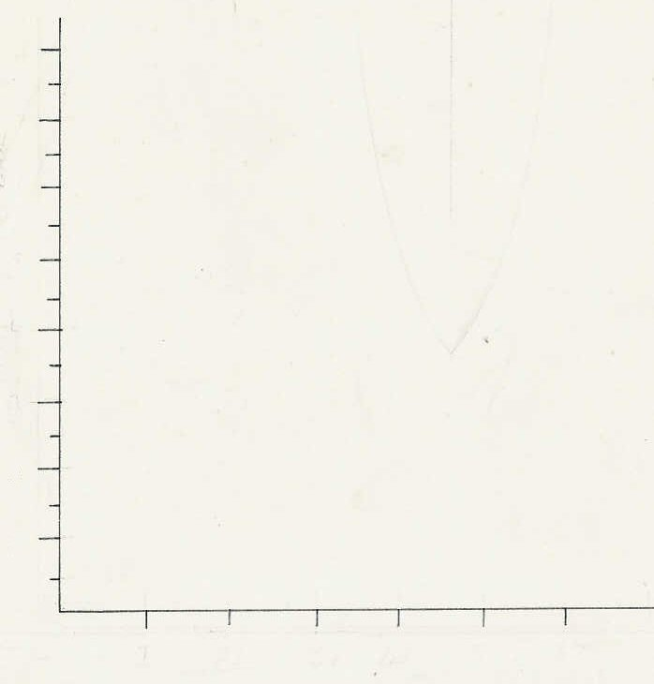
8

7

6

5
length of gas column
4

3

2

1

I
2I
3I
4I
5I
6I
light intensity

Experiment 10a. The effect of light intensity on gas production in pond-weed
Photosynthesis 10a.03

Outline (See experiment 10.) By moving the bench lamp closer to the pond-weed the light intensity is increased by whole number multiples: The volume of gas produced at each intensity is measured.

Prior knowledge A vague understanding of the inverse square law, e.g. that doubling the distance of the light source reduces the light intensity to a quarter. Oxygen is a product of photosynthesis.

Advance preparation and materials-per group

As for experiment 10.
Rule lines on a sheet of paper as shown below

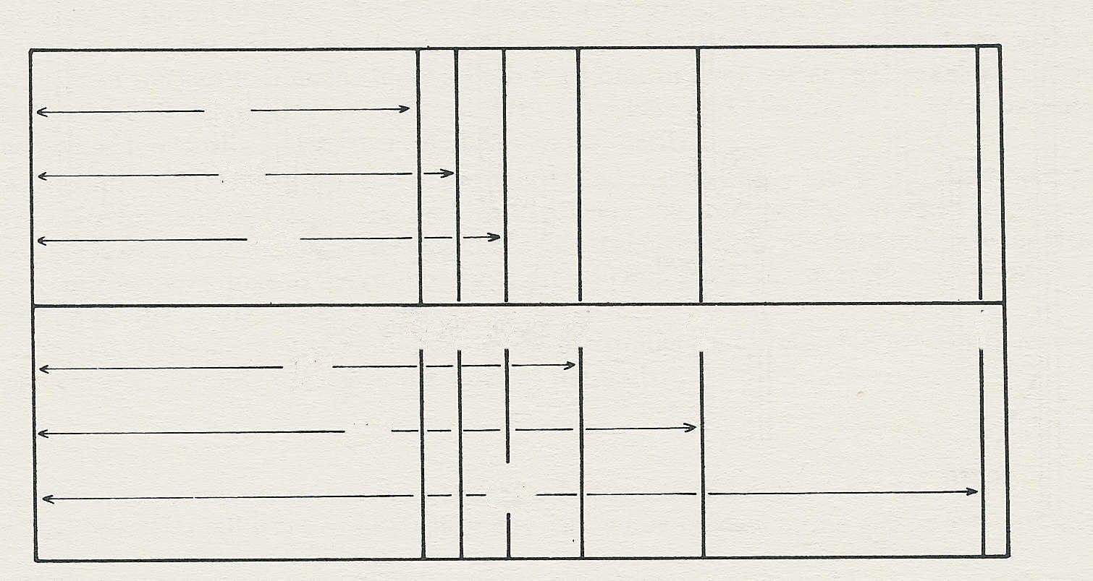
135
148
165
191
233
330
6xI
5xI
4xI
3xI
2xI
I

(distances in mm)

It is advisable to mark the base of each bench lamp so that it can be aligned correctly at each distance

Apparatus

As for experiment 10

NOTES. Water. If there is a reasonable amount of carbon dioxide or calcium hydrogencarbonate in the freshly drawn tap-water, carbon dioxide will probably not be limiting until 5 x I or 6 x I.
If carbon dioxide is deficient it may be necessary to add from 1-5 cm³ 10% sodium hydrogencarbonate to each jar of water.

Black-out. It is advisable to partially black-out the room or at least ensure that there will be no marked changes in light intensity during the experiment.

Results. This experiment should be about 80% successful, i.e. give a nearly straight-line graph with some falling off at the higher intensities.
Experiment 10a. Discussion - answers
Photosynthesis 10a.04

1 An increase in light intensity should bring about an increase in gas production and, until a limiting factor comes into operation, the two should be proportional.

2 Increasing the light intensity makes available a greater amount of energy to drive the photo- synthetic reaction. Since oxygen is a product of photosynthesis, a higher rate of photosynthesis should result in a higher rate of oxygen production.

3 Unless the gas produced by Elodea is pure oxygen it would be possible for the plant to double its oxygen output without doubling the volume of gas if the proportion of oxygen in the gas mixture were increased.

4 One would need to know that the percentage of oxygen in the bubbles remains constant, before
it could be assumed that doubling the volume of gas meant doubling the production of oxygen.

5 It is quite likely that the gas production will increase in direct proportion to the light intensity
over the whole range of this experiment. Limiting factors may operate, however, at the higher light intensities.

6 It is unlikely that gas production would continue to increase indefinitely with increasing light
intensity since carbon dioxide would become limiting or internal factors such as the available chloroplasts or the diffusion rate of carbon dioxide would impose a limit on the rate of photo-
synthesis.

7 As the bench lamp comes closer to the beaker it might be expected that there would be a rise in
temperature of the water in the beaker. Since a rise in temperature speeds up many chemical reactions it might also accelerate some stages of photosynthesis. (In practice, the temperature is unlikely to rise more than l° C.)

