Experiment 10c. The effect of temperature on gas production
Photosynthesis 10c.01

(a) Set up the apparatus with the pond-weed as described on pp. 10.01 & 10.02 and check that it is within easy reach of a Bunsen burner. For this experiment a heat-resisting beaker must be used. A glass jar will not do.
Choose a shoot which is bubbling steadily but at a moderate rather than a rapid rate.

(b) Copy the table given below into your notebook.

(c) Switch on the bench lamp, place it 15 cm from the beaker and do not move it during the experiment.

(d) Place a thermometer in the beaker, resting it in the lip of the beaker so that it does not roll
about but can still be read without removing it. Add two or three pieces of ice to the beaker
and stir the water carefully with the thermometer. Continue adding ice until the temperature
falls to about 15 °C.

(e) At a convenient moment, note the time and remove any gas which has collected in the bulb.

(f) Leave the pond-weed to produce bubbles for an exact number of minutes and then draw the collected gas into the capillary tube. Measure the length of this gas column and record it in your table. Check the temperature and record this also.

(g) Use the syringe to expel air from the capillary tube into the bulb. Remove any remaining ice and heat the water gently with a small Bunsen flame until it reaches about 20 °C. Remove
the flame.

(h) At an appropriate moment, note the time and draw out all the air from the bulb. Leave the plant to produce gas for the same time as before. Draw the collected gas into the graduated capillary, measure its length and record it in your table. Note and record the temperature.

(i) Repeat the experiment at intervals of about 5-10°C according to the time available, up to 50°C.

NOTE
(i) For temperatures above 35 °C it is best to take three successive readings of gas volumes at
each temperature and average the result.
(ii) If bubbles start to appear from parts of the shoot other than the cut stem, a fresh cut should be
made across that part of the stem inserted in the burette.

Temperature | Volume of gas | Time | Volume per minute

Experiment 10c. Discussion
Photosynthesis 10c.02

1 What effect, in general, did a rise in temperature have on the rate of gas production?

2 Why should a change in temperature affect the rate of photosynthesis?

3 In what way, other than its effect on photosynthesis, could a rise in temperature affect the volume of gas escaping from the pond-weed?

4 In this experiment, why is it that an increase in the volume of gas produced is not necessarily
a reliable indication of an increase in the rate of photosynthesis (two reasons)?

5 Was the change in the rate of gas production consistent over the whole range of increasing
temperature? If not, offer an explanation.

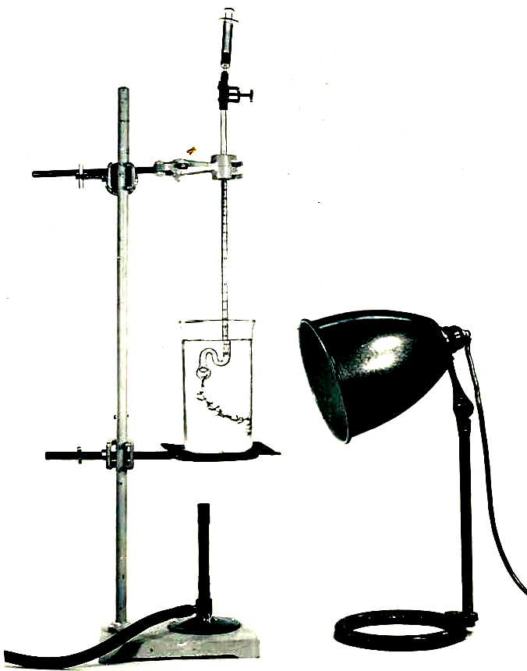

Experiment 10c. The effect of temperature on gas production - preparation
Photosynthesis 10c.03

Outline (See experiment 10 on pp. 10.01 & 10.02) The temperature of the water is raised in 5 or 10° steps and the output of gas is measured.

Prior knowledge Oxygen is a product of photosynthesis.

Advance preparation and materials-per group

As for experiment 10

Apparatus-per group

As for experiment 10 but a tall beaker must be used, not a jar.
Bunsen burner
thermometer

NOTE. At the higher temperatures, gas production may become so rapid that it escapes from parts
of the shoot other than the cut stem. Making a fresh cut across the stem may restore normal bubbling
but it is best if the students choose a shoot with a moderate rather than a rapid rate of bubbling in
the first instance.

Experiment 10c. Discussion - answers

1 A rise in temperature should be accompanied by an increase in gas production.

2 Photosynthesis involves chemical reactions and many chemical reactions are accelerated by heat.

3 The rise in temperature could expand the gas already present in the air spaces of Elodea.

4 (a) A rise in temperature will cause the gas in the burette to expand if it has not already
expanded fully in the plant.
(b) Unless it is known that the composition of the gas does not change, a simple increase in
volume does not prove that the oxygen output has increased. It is oxygen and not any
other gas which is a product of photosynthesis.

5 The increase in gas production is likely to be consistent up to 40° and then fall or fluctuate. Above 45°C the enzymes in the cells will gradually be denatured so eventually arresting the process of photosynthesis.

