Experiment 11. Under what conditions can leaves produce starch in darkness?
Photosynthesis 11.01

(a) Copy the table given below into your notebook.

(b) Label two small beakers or glass jars A and B and add your initials.

(c) In A, place enough 5% glucose solution to half fill it. In B, place an equivalent volume of tap-water.

(d) Cut a leaf from a plant which has been destarched by having been in darkness for 48 hours.

(e) Cut the leaf blade into 4 pieces of about equal area and small enough to fit easily in the beakers or jars.

(f) Test one piece of leaf for starch as described in Experiment 2. If it gives a blue colour, the leaf is unsuitable for the experiment. Further leaves should be selected and tested until one is found which is relatively free from starch.

(g) Float one piece of leaf blade, the right way up, on the surface of the glucose solution in jar A. Push a pin through another piece of leaf and sink it in the glucose solution in jar A. The pin is simply to hold it down in the liquid. Float the remaining leaf portion on the surface of the water in B.

(h) Put both jars in a dark cupboard or under a cardboard box.

(i) After a period of 3-7 days, label three test-tubes AI, A2 and B and test the leaf portions
separately for starch as described in experiment 2. Enter the results in your notebook.

 | Condition | Result of test with iodine | Interpretation
 | Leaf from destarched plant
A1 | Leaf floating on 5% glucose solution
A2 | Leaf submerged in 5% glucose solution
B | Leaf floating on water

Experiment 11. Discussion
Photosynthesis 11.02

1 Under what conditions was the leaf able to produce starch in the absence of light?

2 Suggest explanations to account for the leaf’s failure to produce starch in the other conditions.

3 What additional control experiments would help to support your explanations in 2?

4 Under what conditions and in what parts of a green plant would you expect (a) sugar to be
converted to starch and (b) starch to be converted to sugar?
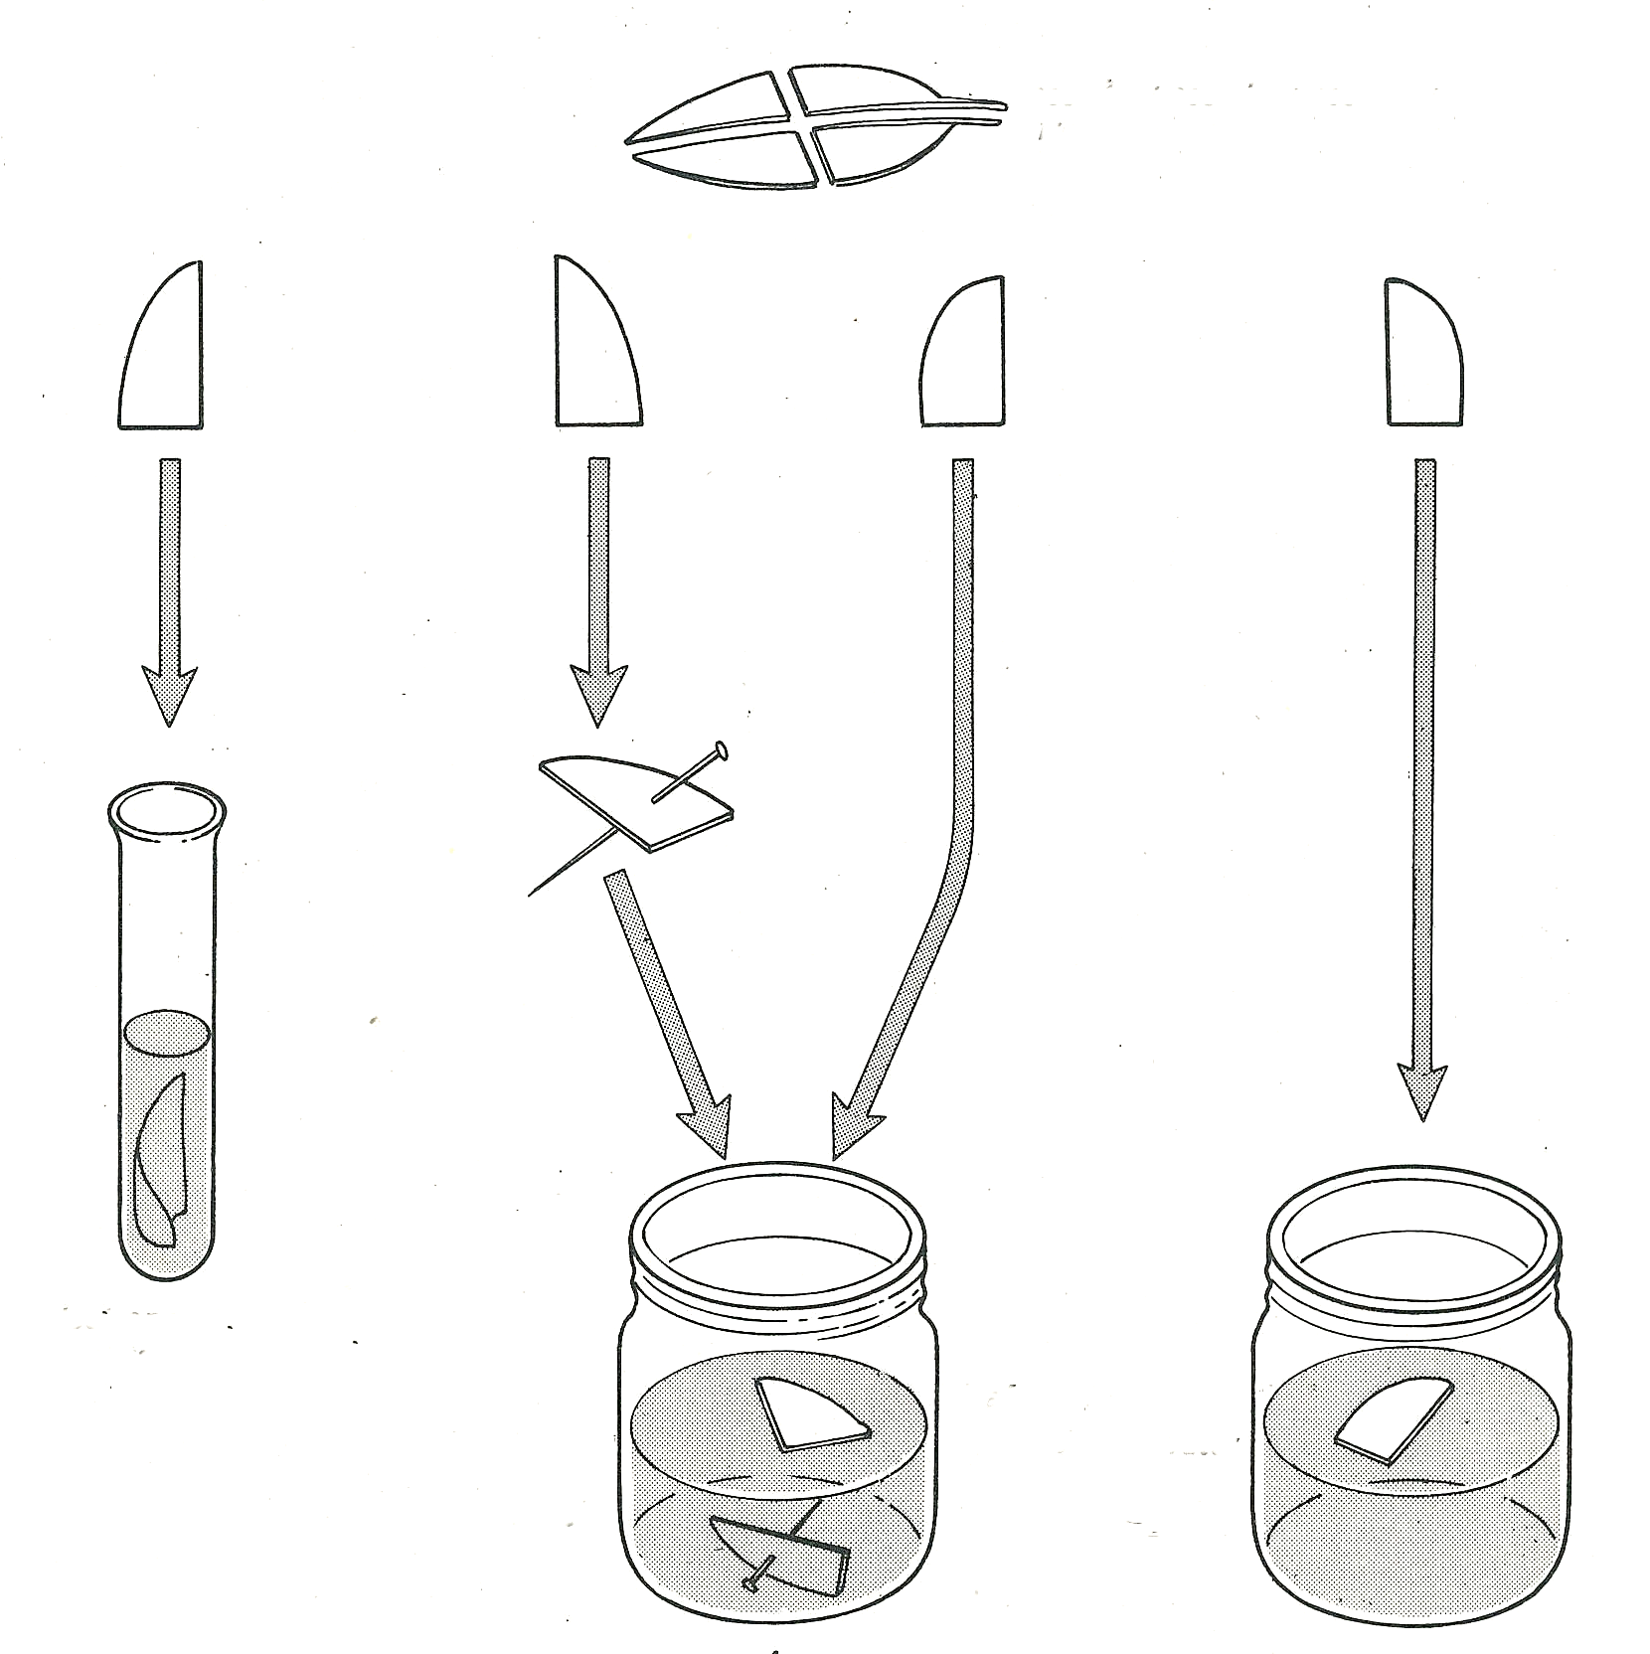

cut four equal pieces from the leaf

test one piece for starch
leaf floating

glucose solution
water
leaf submerged

A
B

Photosynthesis 11.03
Experiment 11. Under what conditions can leaves produce starch in darkness- preparation

Outline Leaf portions are floated on or immersed in glucose solution, kept in darkness for a few days and then tested for starch.

Prior knowledge The process of photosynthesis. Starch is regarded as a product of photosynthesis. The meaning of 'destarched'. The method of testing leaves for starch or follow instructions for Experiment 2

Advance preparation and materials

(a) 5% glucose solution, about 60 cm³

(b) Leaves from destarched plants, e.g. Impatiens (busy Lizzie), broad bean. One leaf per group
is sufficient.

(c) Destarching. For potted plants see Experiment 3, p. 3.03. Outdoor plants; cover the requisite
number of leaves with aluminium foil 2 days before the experiment.

(d) Starch test. See Experiment 2

NOTE. (i) If white parts from a variegated leaf are included in the experiment, it is likely that
they too will show the formation of starch in the dark.
(ii) In hot weather the leaf portions may start to rot after 3-4 days.

Apparatus-per group

2 small beakers or glass jars (e.g. baby food jars) 2 labels or access to spirit marker
pin cupboard space or cardboard box to
scissors, for cutting leaf provide darkness

for testing leaf
3 test-tubes apparatus for starch test as in experiment 2
3 labels

Results Impatiens needs about 4 days to give clear results. Broad bean needs 3 days.

Experiment 11. Discussion - answers
Photosynthesis 11.04

1 Only the leaf portions floating on glucose solution will have produced starch, i.e. exposure to air, and a source of glucose is necessary.

2 (a) The leaves floating on water in darkness are unable to make carbohydrates in the absence
of light and therefore cannot produce starch.
(b) The leaves submerged in glucose are deprived of air. The energy needed to convert
glucose to starch cannot be provided in the absence of oxygen.

3 (a) If leaf portions floating on water were illuminated they should be able to produce starch.
(b) If leaf portions were floated on glucose in an atmosphere of nitrogen or air from which
oxygen had been removed they should fail to produce starch.

4 (a) When sugar is accumulating rapidly in a leaf, or any other part of a plant, it seems probable
that it is converted to starch. In this form it can be stored without upsetting the osmotic
relationships of the cells. These conditions would occur in photosynthesizing leaves or
storage organs.
(b) When the level of sugar starts to fall, one would expect the starch reserves to be converted
to sugar. In this way the osmotic pressure in the cells could be maintained and the
carbohydrate transported in solution. This will occur in leaves during darkness and in storage
organs which are providing carbohydrates for new growth.

