Experiment 12 b. The need for carbon dioxide; using iris leaves
Photosynthesis 12b.01

The iris leaves have been in darkness for at least 4 days. If time permits, test one leaf for sugar as described below from (f) and record the result. If time is short, omit this test and assume that the
leaves are relatively free from sugar.

(a) Label two screw-top jars A and B and add your initials. In A place about 20 g soda lime. In B place about 20 cm³ saturated sodium hydrogencarbonate solution (a test-tube full).

(b) In each jar place a specimen tube containing about 10 cm³ water (50 mm in a test-tube).

(c) Insert one iris leaf in each tube of water, cut off any part of the leaf protruding from the jar and screw the lids on securely.

(d) Place the jars in front of a source of illumination or in a position where they will receive daylight but not direct sunlight. Copy the table below into your notebook.

(e) Leave the jars for 3-4 days in the light and then test each leaf as follows:

(f) In a beaker or can heat some water till it boils and, using forceps, dip the leaf from jar A into the boiling water for a second. Cut the leaf into small pieces over a mortar, add about 2 g clean
sand and grind until the leaf is finely crushed.

(g) Use a graduated pipette or syringe to add 10 cm³ water to the mortar and grind the mixture for a few more seconds before filtering it through a fluted filter paper into a test-tube labelled 'A'.
While waiting for filtration, wash the mortar and start preparing leaf B in the same way, from (f).

(h) When about 20 mm filtrate has collected in the tube add TWO DROPS only of hydrochloric
acid and place the tube in the boiling water bath for 5 minutes.

(i) When tube A has been in the water bath for 5 minutes; use the graduated pipette or syringe to add 5 cm³ Benedict's solution and return the tube to the boiling water for another 5 minutes. Meanwhile, continue the preparation and test with leaf B.

(j) Record in your table the colour in each tube after 5 minutes heating with Benedict's solution.

Result of Benedict’s test
Test on leaf after 4 days in darkness
A. No carbon dioxide present (soda-lime)
B. Carbon dioxide present (sodium hydrogencarbonate

Experiment 12 b. Discussion

1 From the colour of the liquid and precipitate in the test-tubes, which leaf contained more sugar?

2 What evidence is there that sugar is produced during photosynthesis?

3 How can you account, in terms of photosynthesis, for the fact that one leaf produced more sugar?

4 After as much as 4 days in darkness, sugar can still be detected in many iris leaves, whi1e it takes only 48 hours darkness for starch to disappear from the leaves of those plants which normally produce starch. How can you account for this difference?

Experiment 12 b. The need for carbon dioxide; using iris leaves - preparation
Photosynthesis 12b.02

Outline Iris leaves are enclosed in jars containing soda lime or sodium hydrogencarbonate,
exposed to light for 3-4 days and then tested for sugar.

Prior knowledge The test for non-reducing sugar. Soda lime absorbs carbon dioxide. Sodium hydrogencarbonate gives carbon dioxide. Sugar is a product of photosynthesis. How to fold a fluted filter paper (See ‘Enzymes’ Experiment 13).

Advance preparation and materials

(a) Tall, clear glass, screw-top jars with well-fitting lids need to be collected, 2 per experiment.

(b) 'De-sugaring' iris leaves. Cut the top 150 mm from the leaves, place in water and leave in darkness for 3-5 days. Not all the sugar will be metabolized in this time but there will be little enough to make a good comparison with the controls. Allow 2 leaves per experiment.

soda lime, 20 g per experiment
10% sodium hydrogencarbonate solution, 20 cm³ per experiment

Apparatus-per group

fluorescent tube; a 4 ft tube and reflector, set horizontally on its side at bench level will
illuminate 12-14 jars
2 screw-top jars with well-fitting lids, e.g. 200g clear glass coffee jars
2 specimen tubes, e.g. 75 x 25 mm
2 labels or access to spirit marker
receptacles for dispensing soda lime and sodium hydrogencarbonate solution
equipment and materials for testing leaf for sucrose (Experiment 12a).

Experiment 12 b. Discussion - answers

1 The leaf with sodium hydrogencarbonate in the jar should give a fairly convincing yellow, orange or brown precipitate when tested for non-reducing sugar. The leaf deprived of carbon dioxide may give a clear green solution or an opaque green liquid with some orange precipitate. The leaf which had carbon dioxide will therefore appear to have produced more sugar.
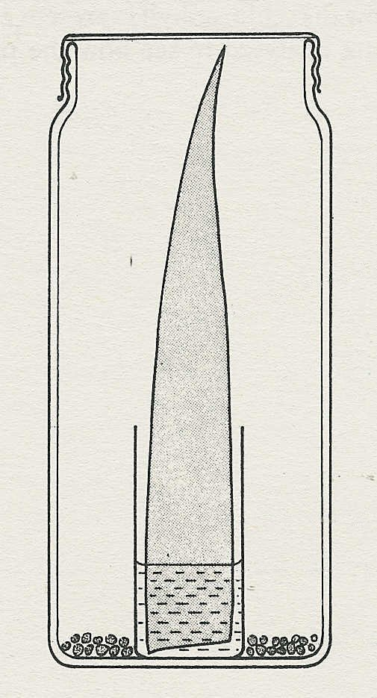
2 If a leaf was tested and found to be relatively free
of sugar at the beginning of the experiment, the
accumulation of sugar in conditions when light,
tall jar
water and carbon dioxide are provided is reasonable
evidence of photosynthesis.
iris leaf
If a leaf was not shown to be free from sugar at
the beginning, an alternative explanation of the
results could be that in the absence of carbon
dioxide, sugar disappears from a leaf, but remains
if carbon dioxide is present.
specimen tube

3 If carbon dioxide is not available, there is no
water
source of carbon for the synthesis of sugar molecules.

4 In darkness, any starch in a leaf is converted to sugar
soda-lime or sodium hydrogencarbonate solution
and therefore does not respond to the iodine test. The
iris leaf, however, does not produce starch and in
darkness the sugar level drops only as fast as it is
metabolized in respiration.

